CHURCH HISTORY TEACHING GUIDE
Arianism and the Trinitarian Defense
Arius, the Council of Nicaea, Athanasius, and Constantinople
A slide-by-slide presenter's study guide for the 26-slide visual history
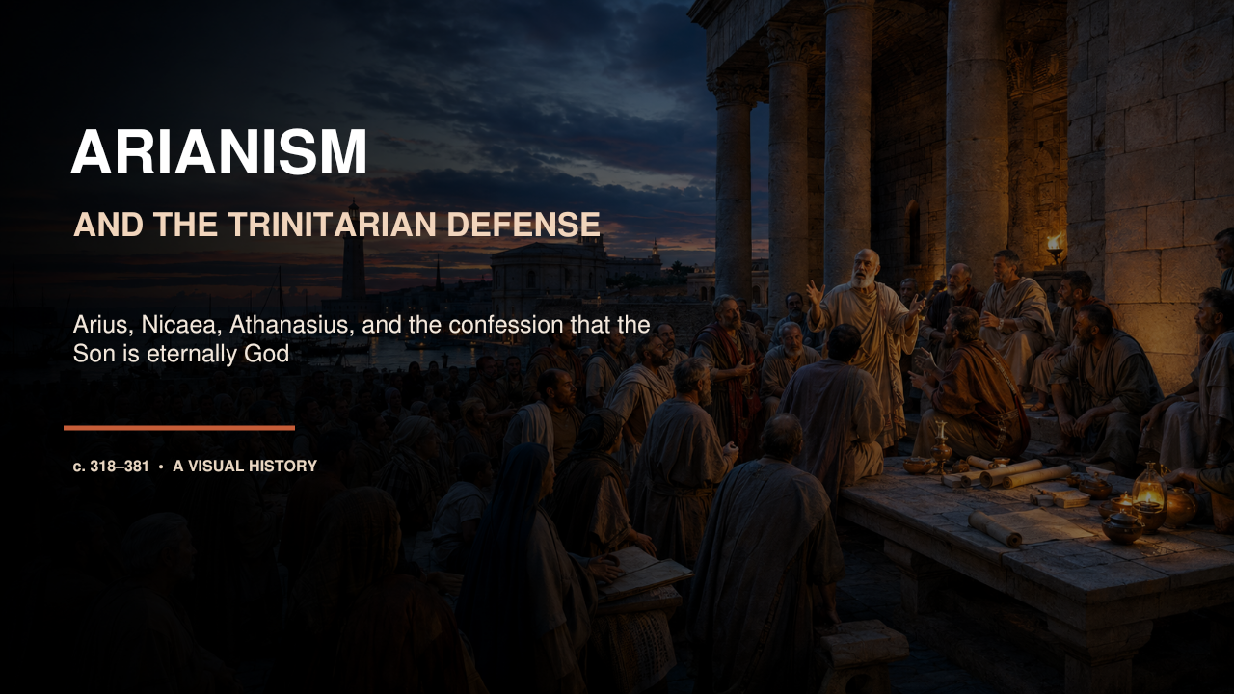
Prepared for teaching, review, and historically responsible discussion

How to Use This Guide
This guide is designed to help you understand the material well enough to present it naturally rather than read the slides aloud. Each slide section gives you a core claim, deeper historical background, a suggested spoken narrative, an accuracy guardrail, and a transition. Study the background first, then adapt the narrative to your own voice and audience.
Recommended pacing. A complete presentation will normally take 55-70 minutes. Plan roughly two minutes for most slides; allow three to four minutes for the biblical texts, the creed, homoousios, and the post-Nicene coalitions. For a 35-minute version, summarize Slides 4-5 together, treat Slides 6-8 as one unit, and compress Slides 19-23 into a single aftermath section.
Teaching approach. Start with the Creator-creature distinction and return to it throughout. Present Arius accurately before explaining the pro-Nicene response. When discussing Nicaea, distinguish episcopal theological judgment from imperial support. Mark the Saint Nicholas story as tradition rather than documented council history.
Pronunciation. Arius: AIR-ee-us. Arian: AIR-ee-un. Athanasius: ath-uh-NAY-shee-us. Nicaea: nye-SEE-uh. Nicomedia: nick-uh-MEE-dee-uh. homoousios: ho-mo-OO-see-os. homoiousios: ho-moy-OO-see-os. ousia: oo-SEE-uh. hypostasis: hy-POSS-tuh-sis. Cappadocian: cap-uh-DOH-shun.

The Story in Six Movements
1. The controlling question Slides 1-3: define the controversy and explain Arius's actual position.
2. Scripture and salvation Slides 4-9: follow the dispute from Alexandria through competing biblical grammars to the stakes for worship and salvation.
3. Nicaea in context Slides 10-14: map the controversy, convene the council, and explain what Nicaea was and was not.
4. The Nicene boundary Slides 15-18: interpret the creed, homoousios, the Saint Nicholas tradition, and the council's immediate result.
5. The long aftermath Slides 19-23: trace rival formulas, Athanasius, and the effects and limits of imperial power.
6. Trinitarian consolidation Slides 24-26: explain the Cappadocians, Constantinople in 381, and the final synthesis.

SLIDE 01

Arianism and the Trinitarian Defense
PowerPoint slide 1
CORE CLAIM The controversy asked whether the Son belongs eternally within the identity of the one God or, as Arius argued, stands on the created side of reality.

Historical Background
The Arian controversy began in Alexandria around 318 and remained a defining theological and political conflict through the Council of Constantinople in 381. Arius did not teach that Jesus was merely human. He taught that the Son existed before the visible universe, made all other creatures, and deserved extraordinary honor. Yet Arius also insisted that the Father alone was unbegotten and without origin. The Son therefore received existence from the Father and did not possess the same underived divine being. Pro-Nicene theologians answered that a Son through whom all created things exist cannot himself be one of the created things.

Suggested Presentation Narrative
Open by separating the historical Arian position from the casual modern use of the word "Arian." Say: "This debate was not about whether Jesus mattered. Both sides called him Lord, Savior, and Son of God. The question was what kind of Son he is." Then introduce the Creator-creature line. Everything that exists is either the uncreated God or something that receives existence from God. Arius placed the Son uniquely high, but still on the receiving, originated side of that line. Nicaea placed the Son within the eternal being of God. Tell the audience that the presentation follows the argument from Alexandria to Nicaea, through decades of conflict, and finally to Constantinople.
Accuracy guardrail. Do not define Arianism as a denial that Jesus is important, preexistent, or in any sense divine. Its decisive claim concerns the Son being originated and unequal in divine being.
Transition. Begin with the four questions that controlled nearly every stage of the controversy.
SLIDE 02

The Dispute Asked Whether the Son Is Truly God
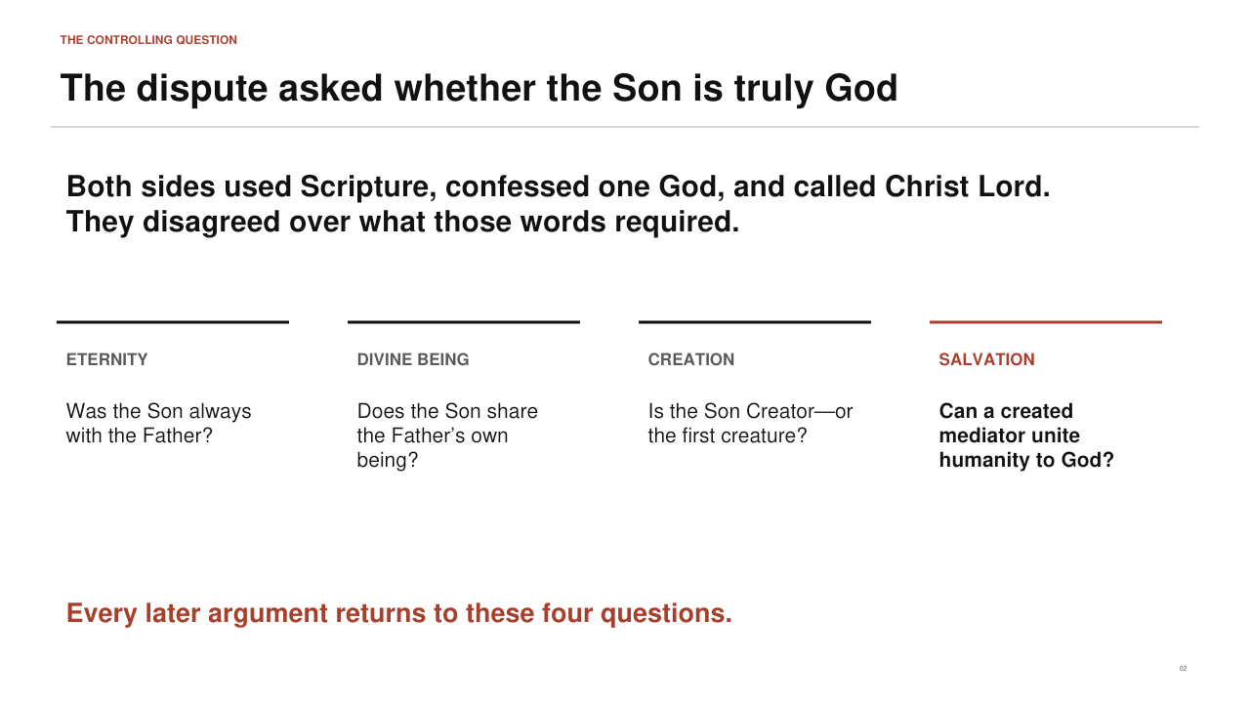
PowerPoint slide 2
CORE CLAIM Eternity, divine being, creation, and salvation were not separate topics; together they tested whether Christian language about Christ was fully monotheistic and fully divine.

Historical Background
Both sides appealed to Scripture and insisted on one God. Both confessed that the Son existed before the world and acted in creation. The disagreement concerned the meaning of those affirmations. If the Son began to exist by the Father's will, he was not eternal in the same sense as the Father. If he did not share the Father's being, his divine titles could be understood as gifts or honors. If he was the first and greatest creature, he could serve as an instrument of creation without being the uncreated Creator. The final question followed: can a created mediator communicate God's own life and save humanity in the fullest Christian sense?

Suggested Presentation Narrative
Use the four headings on the slide as the framework for the whole talk. Under eternity ask, "Was there ever, even before time, when the Son did not exist?" Under divine being ask whether "God" names what the Son is by nature or an honor he receives. Under creation ask whether the Son made absolutely everything created or belongs to that category himself. Under salvation ask whether a creature can do more than point to God - whether he can actually unite humanity to God. Explain that the controversy became so intense because the answer to one question altered the others.
Accuracy guardrail. Avoid saying that the fourth-century parties used one fixed technical vocabulary from the beginning. Terms acquired sharper meanings during the controversy.
Transition. With the controlling questions in view, describe Arius's position in its strongest historical form.
SLIDE 03

Arius Placed the Son Above Creation - but Still Created
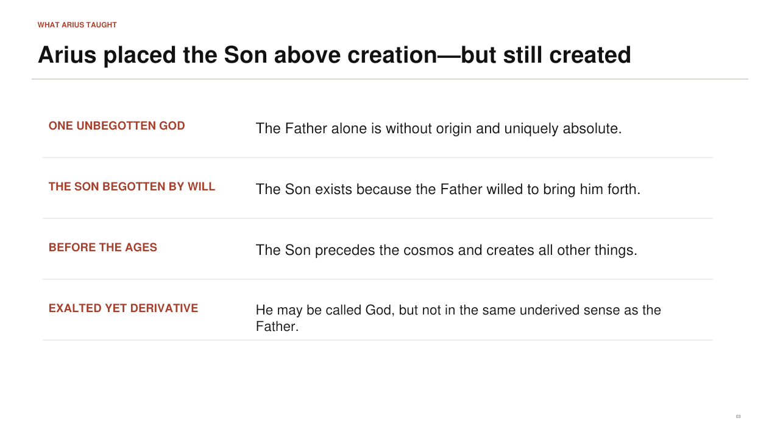
PowerPoint slide 3
CORE CLAIM Arius protected the Father's unique transcendence by treating the Son as the highest being produced by the Father's will.

Historical Background
Arius began from the conviction that the Father is alone unbegotten, without source, and absolutely unique. Because Father and Son are distinct, Arius concluded that the Son cannot possess the Father's unoriginated mode of existence. The Son was begotten before times and ages, not as part of the material cosmos, and all other creatures came through him. Nevertheless, the Son had a beginning dependent on the Father's will. Arius could call the Son God, Word, Wisdom, and only-begotten, but those titles did not mean that the Son shared the Father's identical divine essence without beginning.

Suggested Presentation Narrative
Present Arius fairly before criticizing him. Walk down the slide: one unbegotten God; a Son brought forth by will; a Son before the ages; a Son exalted above every creature. Then say that the last step is the decisive one: exalted does not mean uncreated. A helpful formulation is, "Arius gave the Son the highest possible place beneath the Father, while Nicaea denied that there is any place between the uncreated God and creation." This allows the audience to understand why Arius thought he was defending monotheism and why his opponents thought he had altered Christian worship and salvation.
Accuracy guardrail. The slogan "there was when he was not" expresses the logic opposed at Nicaea, but avoid treating every later non-Nicene theologian as holding Arius's entire original system.
Transition. This theology first became a public crisis inside the church of Alexandria.
SLIDE 04

A Local Dispute Became an Empire-Wide Crisis
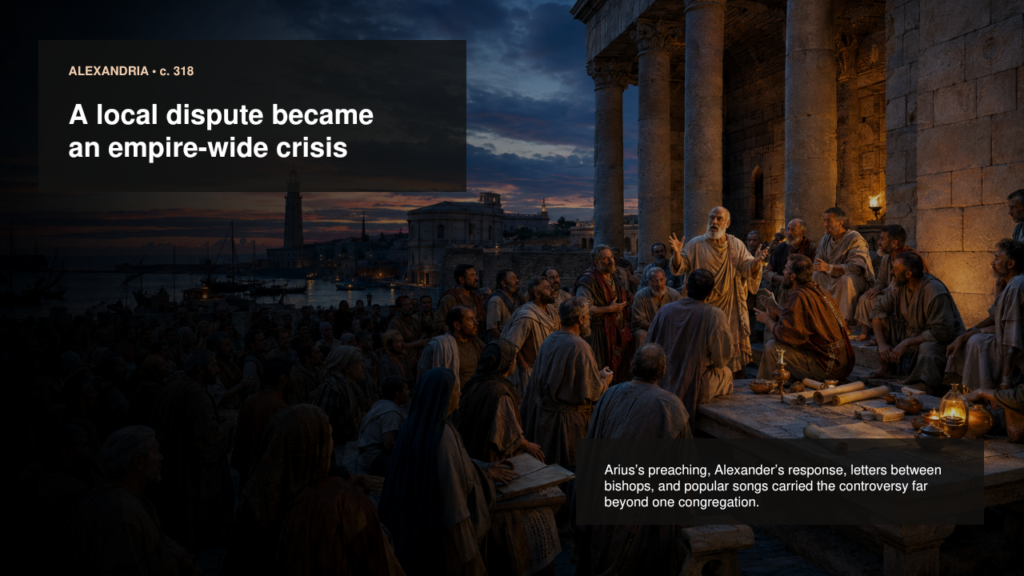
PowerPoint slide 4
CORE CLAIM The controversy spread because theology moved through preaching, letters, episcopal alliances, synods, songs, and imperial communications.

Historical Background
Arius was a presbyter under Alexander, bishop of Alexandria. The immediate beginning of the dispute is described differently in later sources, but Alexander condemned Arius and his supporters in a local synod. Arius sought support from influential bishops, especially Eusebius of Nicomedia, and circulated explanations of his teaching. Alexander and later his deacon Athanasius answered through letters and theological argument. Alexandria was one of the empire's greatest intellectual and ecclesiastical centers, so a conflict there readily reached Palestine, Syria, Asia Minor, and the imperial court.

Suggested Presentation Narrative
Use the image to make the conflict social rather than purely academic. Arius preached to a congregation; Alexander had responsibility for the unity and teaching of the Alexandrian church; other bishops received letters asking them to take sides. Popular verse and song could make theological slogans memorable beyond formal schools. Emphasize that bishops were connected across the Mediterranean. A local condemnation did not silence Arius because he could appeal to a wider network. By the time Constantine became involved, the quarrel had already become international within the church.
Accuracy guardrail. Our narratives of the opening dispute come mainly from partisan sources. Be firm about the broad sequence and cautious about reconstructing exact private conversations.
Transition. The source problem becomes especially important when we try to quote Arius himself.
SLIDE 05

The Controversy Turned on the Identity of the Son
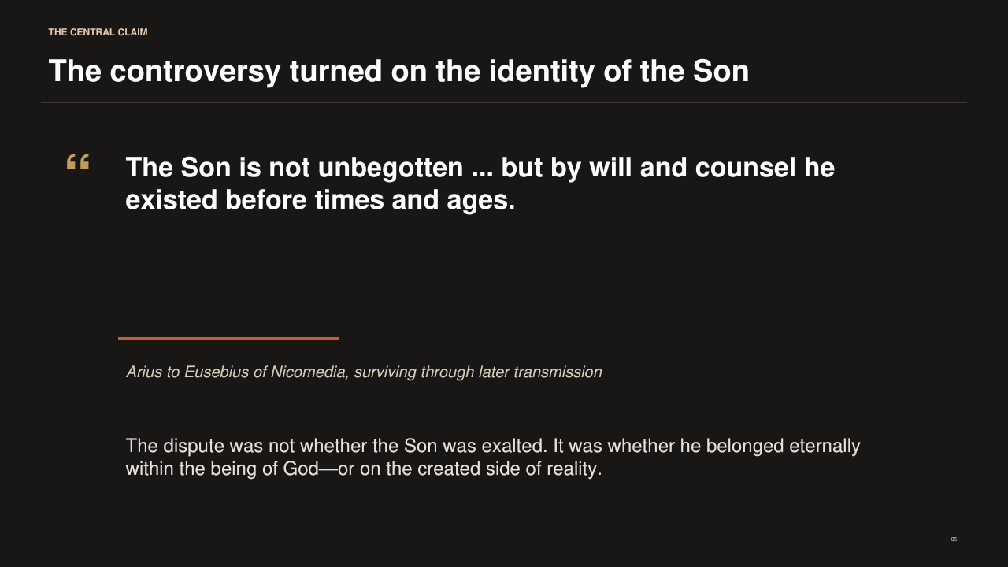
PowerPoint slide 5
CORE CLAIM Arius's surviving words show a preexistent Son brought forth by the Father's will, while the fragmentary record requires careful interpretation.

Historical Background
Only a small amount of Arius's writing survives, including letters and fragments preserved in later collections or quoted by opponents. His letter to Eusebius of Nicomedia states that the Son is not unbegotten and that he existed before times and ages by the Father's will and counsel. Other reported phrases include "there was when he was not" and the claim that the Son came from things that were not. These formulations were later rejected in the anathemas attached to the creed of 325.

Suggested Presentation Narrative
Read the quotation slowly. First stress "before times and ages," because Arius did not imagine Christ beginning at Bethlehem. Then stress "by will and counsel," because the Son's existence is derivative rather than eternally necessary to the Father's identity. Explain that historians must distinguish a direct letter from polemical summaries and hostile quotations. We can identify the structure of Arius's position, but we should not pretend that a complete, neutral edition of all his theology survives.
Accuracy guardrail. Do not build a detailed psychological portrait of Arius from hostile descriptions. Discuss his documented claims and their theological implications.
Transition. Next show how Arius and his allies believed Scripture supported this hierarchy.
SLIDE 06

Arius Read Biblical Subordination as Ontological Inequality
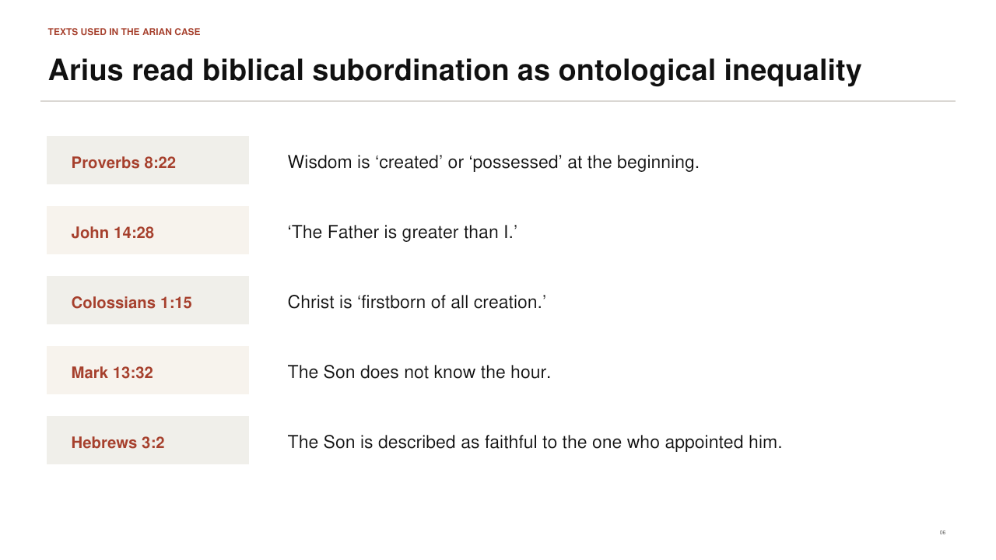
PowerPoint slide 6
CORE CLAIM Arian exegesis treated biblical language of appointment, obedience, limitation, and priority as evidence that the Son possesses a lesser kind of being.

Historical Background
Proverbs 8:22 was central because early Christians commonly identified divine Wisdom with the preexistent Son; depending on translation, Wisdom says that God "created" or "possessed" her at the beginning. John 14:28 says that the Father is greater than the Son. Colossians 1:15 calls Christ the firstborn of all creation. Mark 13:32 says that the Son does not know the final hour, and Hebrews 3:2 speaks of Christ as faithful to the one who appointed him. Read together, such passages seemed to describe derivation, hierarchy, limitation, and obedience.

Suggested Presentation Narrative
Do not dismiss these as obviously foolish prooftexts. Explain the Arian reading of each one, then show that interpretation requires a larger grammar. "Firstborn" can mean the first member of a class, but it can also express supremacy and inheritance. "The Father is greater" can be read as a statement about the incarnate mission rather than unequal divine nature. The Son's ignorance can be discussed in relation to the incarnation. The key issue is whether descriptions of Christ's economic role - what he does in salvation - directly define his eternal being.
Accuracy guardrail. Different ancient translations of Proverbs 8:22 mattered. Avoid claiming that one English rendering alone decides the fourth-century debate.
Transition. The pro-Nicene response did not ignore those texts; it placed them beside passages identifying the Son with divine creation, honor, and eternity.
SLIDE 07

The Trinitarian Defense Began with Scripture's Creator-Creature Boundary
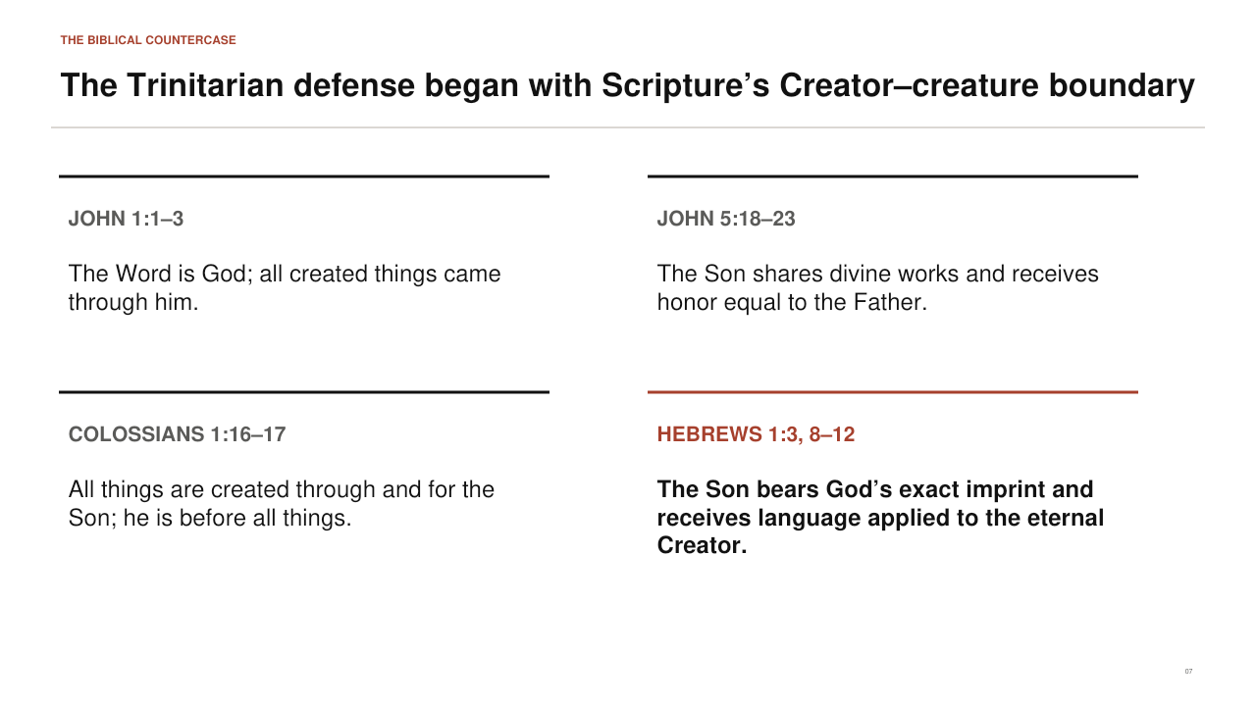
PowerPoint slide 7
CORE CLAIM The cumulative biblical case places the Son among neither angels nor creatures but within God's own creating, ruling, and life-giving identity.

Historical Background
John 1:1-3 both distinguishes the Word from God the Father and calls the Word God; it then says that all things that came to be came through him. John 5:18-23 associates the Son with the Father's life-giving and judging work and requires equal honor for Father and Son. Colossians 1:16-17 explains firstborn through universal creation: all things are through and for Christ, and he is before all things. Hebrews 1 calls the Son the radiance of divine glory and exact imprint of God's being, addresses him as God, and applies Creator language to him.

Suggested Presentation Narrative
The strongest presentation is cumulative. Do not claim that a single isolated word settles everything. Ask: "If all created things came through the Word, can the Word be one of the things that came to be?" Then ask why the Son receives the same honor as the Father and performs works Scripture identifies with God. Explain that pro-Nicene theologians maintained a real distinction between Father and Son while refusing to place the Son outside the divine identity. Their argument was not Father equals Son as persons; it was that the distinct Son shares what God eternally is.
Accuracy guardrail. Do not collapse the Father and Son into one person. Pro-Nicene theology defended both unity of divine being and genuine personal distinction.
Transition. The next slide explains why both parties could quote Scripture yet reach opposite conclusions.
SLIDE 08

Two Theological Grammars Organized the Same Texts
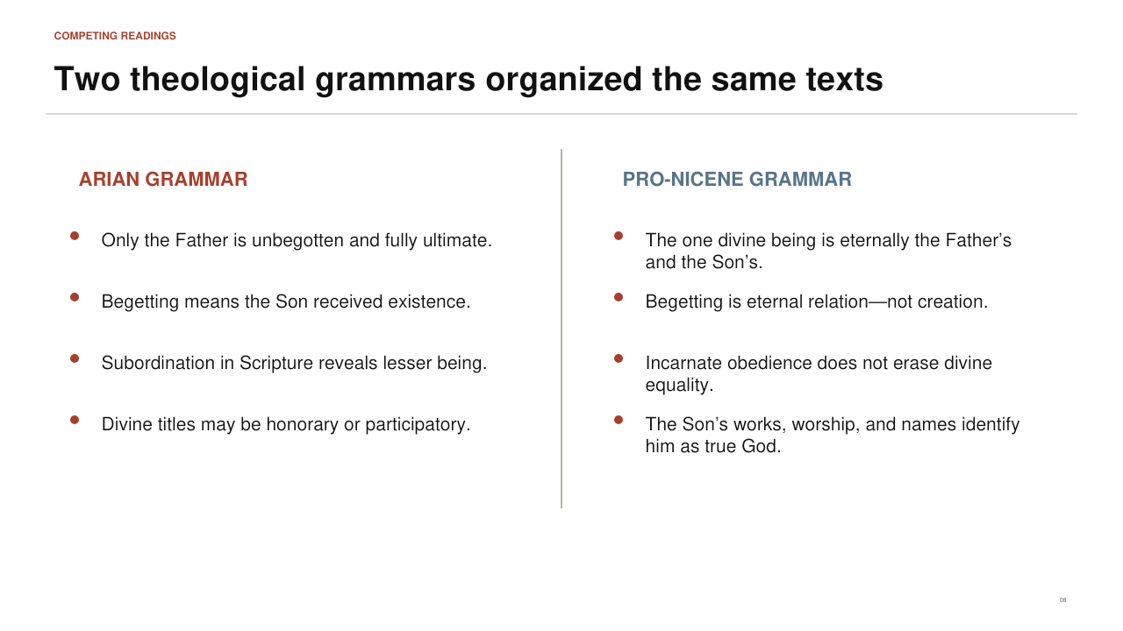
PowerPoint slide 8
CORE CLAIM Prooftexts did not settle the dispute because each party interpreted them within a different account of begetting, divine unity, incarnation, and salvation.

Historical Background
The Arian grammar began with the Father as the only unbegotten reality. Begetting therefore indicated that the Son received existence and was subordinate in being. Divine titles could be used by participation or honor. The pro-Nicene grammar treated begetting as an eternal relation within God rather than an act of creation. Texts of obedience, growth, suffering, or limitation were read through the incarnation: the divine Word truly assumed human nature and carried out the Father's saving mission. Texts of creation, worship, eternity, and divine action disclosed what the Son is by nature.

Suggested Presentation Narrative
Contrast the columns without suggesting that one side had Scripture and the other had philosophy. Both used biblical language and conceptual reasoning. Explain the difference between "economic" and "ontological." Economic language concerns the ordered mission of Father, Son, and Spirit in creation and salvation. Ontological language concerns what the Son is in relation to the divine being. Pro-Nicenes argued that obedient mission does not imply lesser essence, just as personal distinction does not imply separation into multiple gods.
Accuracy guardrail. The labels summarize tendencies. Individual theologians changed positions, used terms differently, and sometimes resisted the vocabulary of both columns.
Transition. Why did this interpretation matter so much? Because it affected Christian worship and the meaning of salvation.
SLIDE 09

A Created Son Destabilizes Worship and Salvation
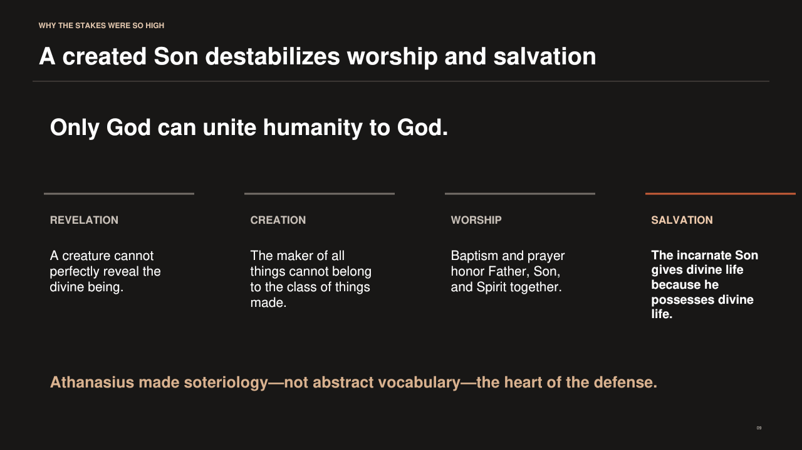
PowerPoint slide 9
CORE CLAIM For Athanasius and other pro-Nicenes, only the truly divine Word can reveal God perfectly, create all things, receive divine worship, and communicate divine life.

Historical Background
Athanasius repeatedly connected Christology with salvation. Creatures receive life, grace, holiness, and incorruption; they do not possess these gifts from themselves. If the Son is a creature, he too requires what he is supposed to give. If the Son is the Father's own eternal Word and Image, however, he can make the Father known and restore the divine image in humanity. Christian baptism, prayer, doxology, and worship already placed the Son with the Father. Pro-Nicenes believed Arianism made this worship either idolatrous or internally inconsistent.

Suggested Presentation Narrative
Move through revelation, creation, worship, and salvation. Under revelation explain that a created intermediary cannot be the perfect self-expression of the uncreated God. Under creation repeat that the maker of everything created cannot belong to the created totality. Under worship ask why Christians are baptized into and bless Father, Son, and Holy Spirit together. Under salvation explain Athanasius's key logic: the Son gives what belongs to God because he is God by nature, not a creature promoted by grace. This is the emotional and pastoral center of the controversy.
Accuracy guardrail. Explain "deification" as participation in divine life by grace, not humans becoming gods by nature or ceasing to be creatures.
Transition. The theological dispute spread across the same roads and cities that connected the imperial church.
SLIDE 10

Doctrine Spread Through Letters, Synods, and Imperial Roads
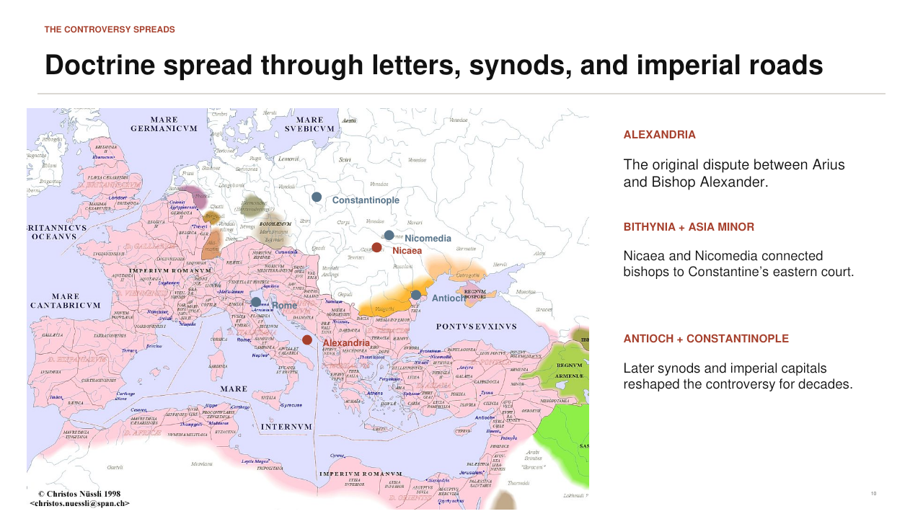
PowerPoint slide 10
CORE CLAIM Alexandria, Nicomedia, Nicaea, Antioch, Constantinople, and Rome became connected centers in a controversy carried by both church and empire.

Historical Background
Alexandria was the original center. Arius found an important ally in Eusebius of Nicomedia, whose city was close to the eastern imperial court. Nicaea in Bithynia became the council site in 325. Antioch hosted important synods and produced alternative formulas after Nicaea. Constantinople became the imperial capital and the site of the council of 381. Rome mattered through western episcopal support, exiled eastern bishops, and wider claims of communion. Geography helps explain how local theological disputes became questions of imperial peace.

Suggested Presentation Narrative
Orient the audience carefully. Begin at Alexandria in Egypt, move north and east to Antioch, then northwest through Asia Minor to Nicaea and Nicomedia, and finally to Constantinople. Point westward to Rome. Explain that bishops traveled, carried letters, assembled in synods, and appealed to emperors. Imperial roads did not carry doctrine automatically, but they made rapid ecclesiastical coordination and political enforcement possible. The marked cities are representative nodes, not a complete map of every church affected.
Accuracy guardrail. Do not describe the map as a statistical heat map or imply that every city held one stable position throughout the century.
Transition. Constantine responded to this geographically spreading conflict by convening a council at Nicaea.
SLIDE 11

Constantine Convened the First Empire-Wide Council
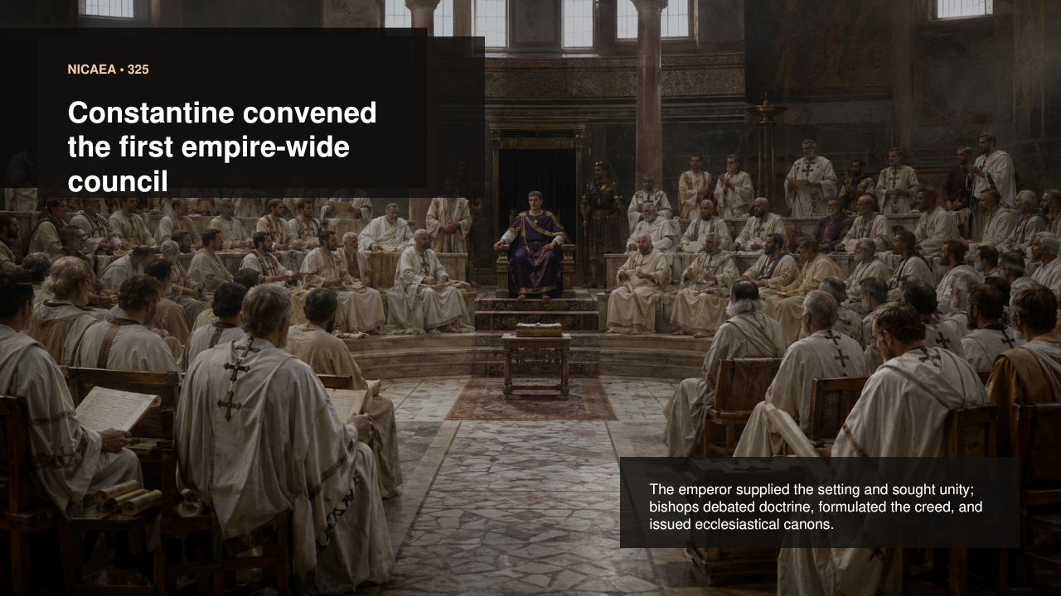
PowerPoint slide 11
CORE CLAIM Nicaea joined episcopal deliberation to imperial support: Constantine provided the setting and enforcement, while bishops debated, confessed, and legislated.

Historical Background
After defeating Licinius in 324, Constantine ruled the whole empire and encountered the eastern controversy as a threat to church and civic concord. He first attempted reconciliation, then summoned bishops to Nicaea in 325. The emperor funded travel, attended portions of the gathering, encouraged agreement, and later enforced its decisions. The bishops examined the disputed teaching, produced a creed and anathemas, addressed the date of Easter, responded to the Melitian schism, and issued twenty disciplinary canons.

Suggested Presentation Narrative
Introduce Nicaea as an unprecedented scale of episcopal consultation under a Christian-favoring emperor. State both sides of the partnership. Constantine was not a passive observer; his resources, presence, unity agenda, and penalties mattered. Yet the council was not a private imperial theology lecture. Bishops brought earlier rules of faith, baptismal confession, biblical arguments, local controversies, and ecclesiastical authority. A balanced sentence is: "The emperor convened and enforced; the bishops debated and defined."
Accuracy guardrail. Do not say Constantine invented the Trinity, dictated the creed by himself, or made Christianity the official religion at Nicaea.
Transition. Before examining the creed, define precisely what kind of council Nicaea was.
SLIDE 12

Nicaea Was a Council of Bishops Answering a Defined Church Crisis
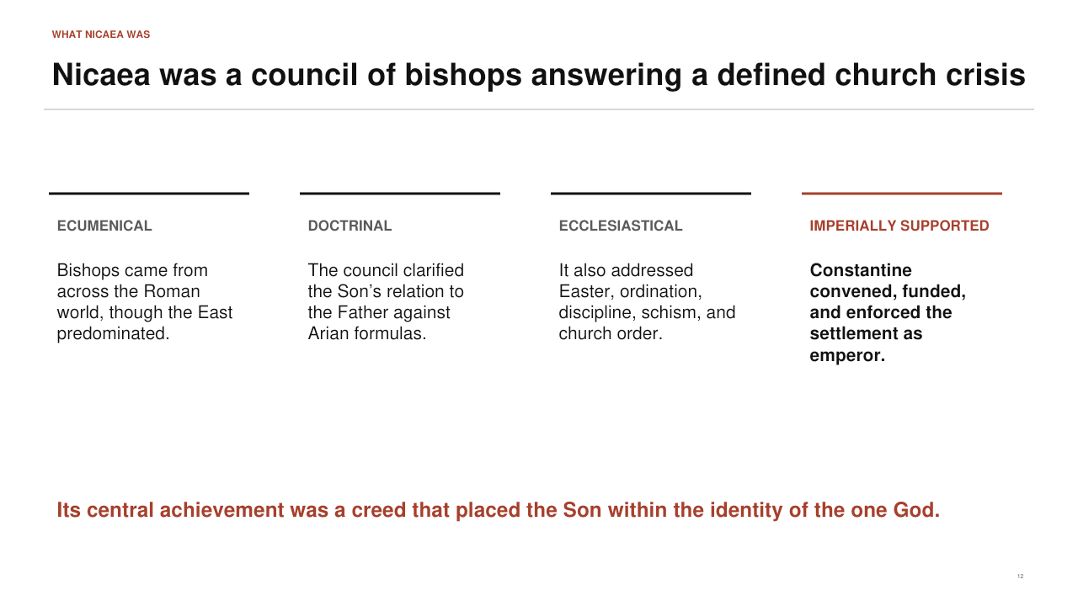
PowerPoint slide 12
CORE CLAIM Nicaea was ecumenical in scope, doctrinal in its central dispute, ecclesiastical in its wider business, and materially supported by imperial power.

Historical Background
"Ecumenical" comes from the idea of the inhabited world and, in later church usage, designates a council received as representing the universal church. Most bishops at Nicaea came from the Greek-speaking East because of distance and demographics, but participants also represented western regions. The Arian controversy supplied the defining doctrinal problem. The council also dealt with Easter, ordination, reconciliation of schismatics, clergy discipline, jurisdiction, and other matters through its canons. Constantine wanted concord across the church and empire and supplied the conditions for an unusually broad assembly.

Suggested Presentation Narrative
Use the four headings to resist a one-dimensional story. Explain that ecumenical does not mean every bishop in the world attended or that all later churches use the term in precisely the same institutional way. Doctrinal means the council drew a public boundary around confession of the Son. Ecclesiastical means it also governed practical church life. Imperially supported means the emperor made the gathering possible and treated its decisions as politically important. End with the central achievement: the creed placed the Son within the identity of the one God.
Accuracy guardrail. Do not reduce Nicaea to the single word homoousios; the creed's full sequence and the council's canons reveal a broader act of confession and governance.
Transition. The clearest way to understand Nicaea is also to say what it did not do.
SLIDE 13

Nicaea Did Not Invent Christianity's Doctrine or Bible
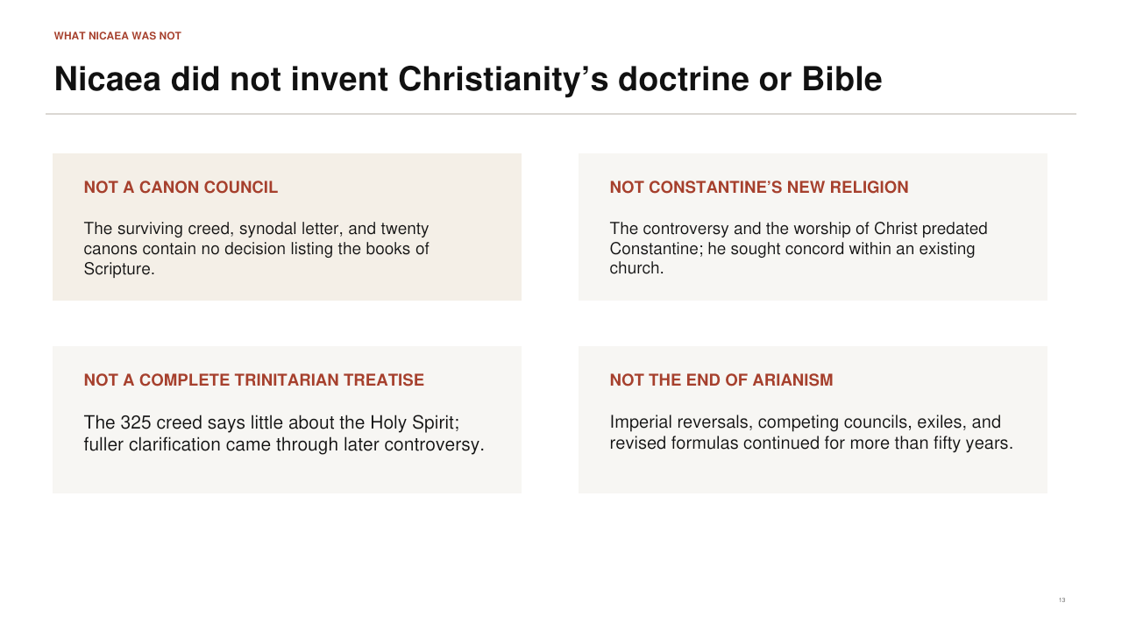
PowerPoint slide 13
CORE CLAIM The council neither selected the biblical canon nor created belief in Christ's deity, and it did not finish every later Trinitarian question.

Historical Background
No surviving creed, synodal letter, or canon of Nicaea contains a list of biblical books. Stories that bishops voted on the Bible at Nicaea are modern myths, not conclusions from the council's surviving acts. Christian worship of Christ, baptismal formulas, theological reflection, and disputes over Father and Son long predated Constantine. The 325 creed made a focused statement about the Son and offered only a brief confession of the Holy Spirit. It did not use the later settled formula "one essence and three hypostases," and it did not end anti-Nicene theology or imperial intervention.

Suggested Presentation Narrative
Treat this slide as myth correction, not ridicule. Say what Nicaea actually left us: a creed, anathemas, a synodal letter, and twenty canons. None records a canon-of-Scripture decision. Explain that councils clarify doctrine because disputes force inherited beliefs to be expressed more precisely. They do not necessarily create the worship and scriptural reading they defend. Finally, point out that the Holy Spirit receives only a short clause in 325, which is one reason the story must continue to 381.
Accuracy guardrail. Avoid the opposite exaggeration that Nicaea merely repeated unchanged language. Homoousios and the anathemas were consequential clarifications with a contested reception.
Transition. Now move inside the council and review its date, participants, agenda, and documentary results.
SLIDE 14

The Council Sought a Public Rule of Faith for a Fractured Church
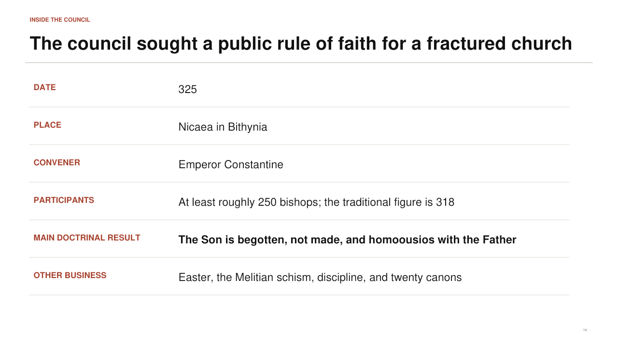
PowerPoint slide 14
CORE CLAIM The secure facts are clearer than the popular exact numbers: Nicaea met in 325, gathered a broad eastern-majority episcopate, and adopted a strongly anti-Arian creed.

Historical Background
The council met at Nicaea in Bithynia in 325. Ancient attendance reports and surviving lists vary. Eusebius of Caesarea speaks of more than 250 bishops, while the number 318 became traditional and symbolically important. Constantine convened the assembly. The main doctrinal result confessed the Son as begotten from the Father's essence, true God from true God, begotten not made, and homoousios with the Father. The attached anathemas rejected the claims that the Son once did not exist, came from nonbeing, or was of another essence or subject to moral change.

Suggested Presentation Narrative
Read the fact panel without creating false drama around a vote count. Explain that exact attendance is uncertain because ancient sources and lists differ. The important historical conclusion is that the final creed achieved very broad assent and left only a small opposition. Mention the other business because it shows a functioning council, not a single debate staged for modern textbooks. If the audience asks what records survive, name the creed and anathemas, synodal letter, canons, Eusebius's letter to his church, and later historical narratives - not a modern verbatim transcript.
Accuracy guardrail. Do not claim that 318 is a certain head count or that a precise modern-style roll-call vote survives.
Transition. The creed itself shows how the council closed off characteristic Arian interpretations.
SLIDE 15

The Nicene Creed Blocked Arian Evasions
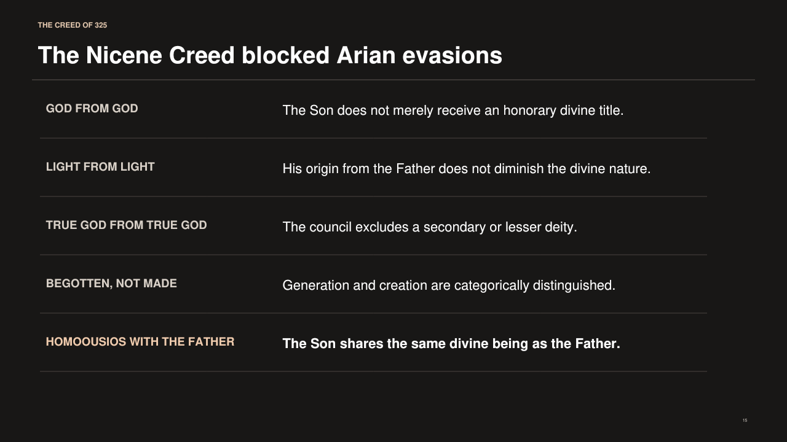
PowerPoint slide 15
CORE CLAIM The creed used a sequence of mutually reinforcing clauses to say that the Son is genuinely and eternally divine, not a secondary god or supreme creature.

Historical Background
"God from God" and "true God from true God" prevent divine language from being reduced to an honorary title. "Light from Light" uses an image of communicated reality without division or diminution: light proceeds from light while remaining what light is. "Begotten, not made" establishes a categorical difference between the Son's eternal relation to the Father and the creation of everything else. "Homoousios with the Father" states that the Son shares the Father's own divine essence or being. The anathemas then reject several formulas associated with Arius.

Suggested Presentation Narrative
Read the clauses cumulatively, leaving homoousios until last. Explain that ordinary biblical titles such as Son, Word, Wisdom, and even God could be reinterpreted within an Arian hierarchy. The creed therefore adds phrases that make the intended meaning explicit. Emphasize "begotten, not made." Begetting names relation to the Father; making names the origin of creatures. The council did not claim that the Son is another unbegotten Father. It confessed that the Son eternally receives the one undivided divine being as Son.
Accuracy guardrail. The creed recited in many churches today is the later Niceno-Constantinopolitan form, not word-for-word identical to the shorter creed promulgated at Nicaea in 325.
Transition. Focus next on homoousios, the term that became the council's most famous boundary marker.
SLIDE 16

Homoousios Protected the Creator-Creature Distinction
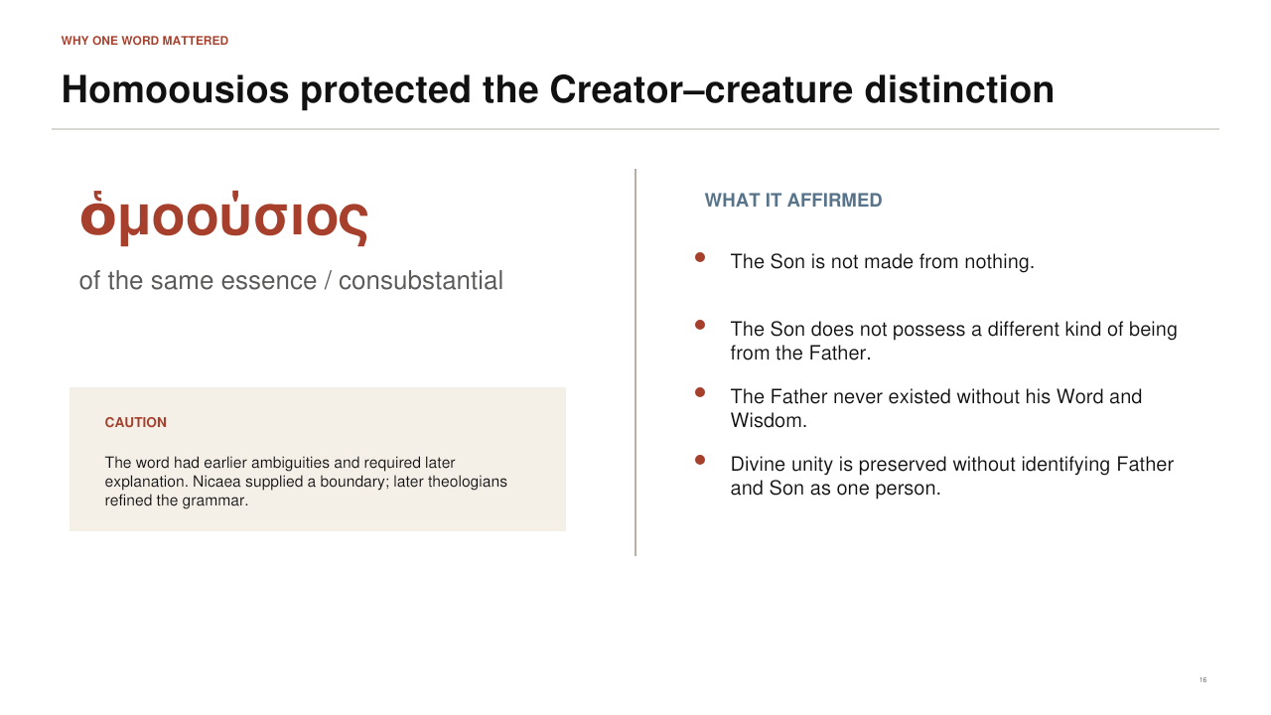
PowerPoint slide 16
CORE CLAIM Homoousios means that the Son possesses the same divine essence as the Father; it excludes both creation from nothing and a lesser species of divinity.

Historical Background
The Greek word homoousios is commonly translated "of the same essence," "of one being," or "consubstantial." It does not mean that Father and Son are the same person. Rather, it denies that the Son is made from nonbeing or possesses a different created nature. The term had a complicated prehistory and could be misunderstood in material or modalistic ways. Some bishops accepted the council while interpreting the word cautiously; others preferred scriptural expressions and feared that essence language blurred personal distinction. Later theology clarified its proper use.

Suggested Presentation Narrative
Pronounce the word ho-mo-OO-see-os and break it into homo, "same," and ousia, "essence" or "being." Then call it a boundary term. It does not explain every mystery of the Trinity, but it tells the church where the Son cannot be placed: outside God, among things made, or in a lesser divine category. Clarify that the Father remains Father and the Son remains Son. Their distinction is relational and personal, while the divine nature is one. This is the bridge to the later Cappadocian formula.
Accuracy guardrail. Do not translate homoousios as "the same person." Also do not imply that every bishop immediately understood or defended the term in the same later technical sense.
Transition. Before discussing the council's result, pause for the famous story of Saint Nicholas and separate tradition from documentation.
SLIDE 17

Did Saint Nicholas Punch Arius?
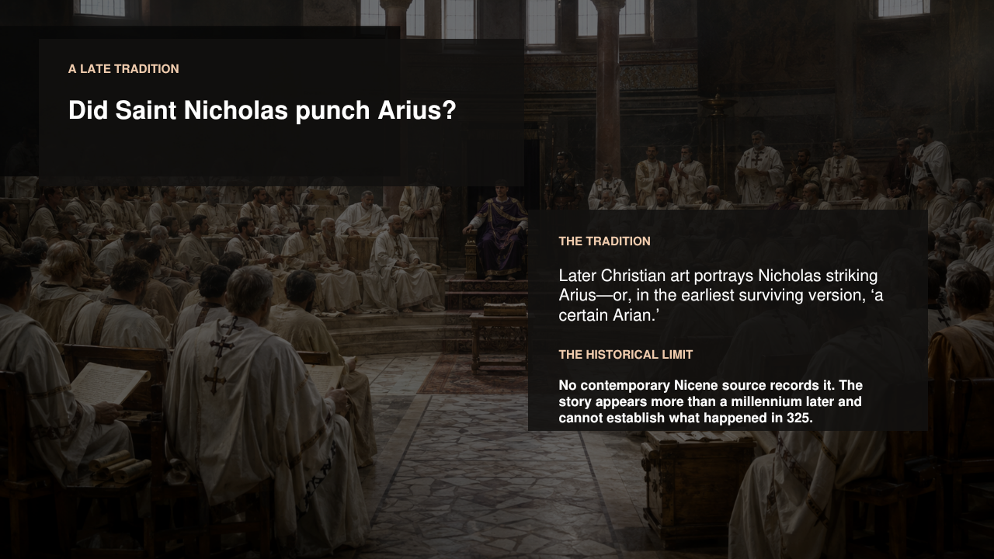
PowerPoint slide 17
CORE CLAIM The story is a beloved late tradition, not a documented event in the contemporary or early accounts of Nicaea.

Historical Background
Modern retellings often say that Nicholas of Myra became so angered by Arius's teaching that he struck him during the council, was stripped of episcopal insignia, and was restored after a vision of Christ and the Virgin. No contemporary Nicene source records the blow. The earliest located form appears in a late fourteenth-century Greek account and speaks of Nicholas striking "a certain Arian"; later versions identify the opponent as Arius and add details. Even Nicholas's attendance at Nicaea is not securely established by contemporary evidence.

Suggested Presentation Narrative
Tell the story as tradition first, because that respects how it functions in Christian memory. Then change tone and identify the historical limit. Say: "This may express later devotion to Nicholas as a defender of orthodoxy, but it cannot be used as evidence for what happened in 325." Explain the difference between theological meaning and historical verification. A story can communicate zeal for the deity of Christ while remaining chronologically late and unsupported by council records. This is an excellent moment to model reverence without confusing hagiography with contemporary documentation.
Accuracy guardrail. Do not present the punch as fact, do not claim that the earliest version names Arius, and do not use the image as a literal reconstruction of the event.
Transition. Return from the legend to the council's securely documented result: broad assent, condemnation, and imperial enforcement.
SLIDE 18

Nicaea Produced a Strong Consensus - but Not Instant Peace
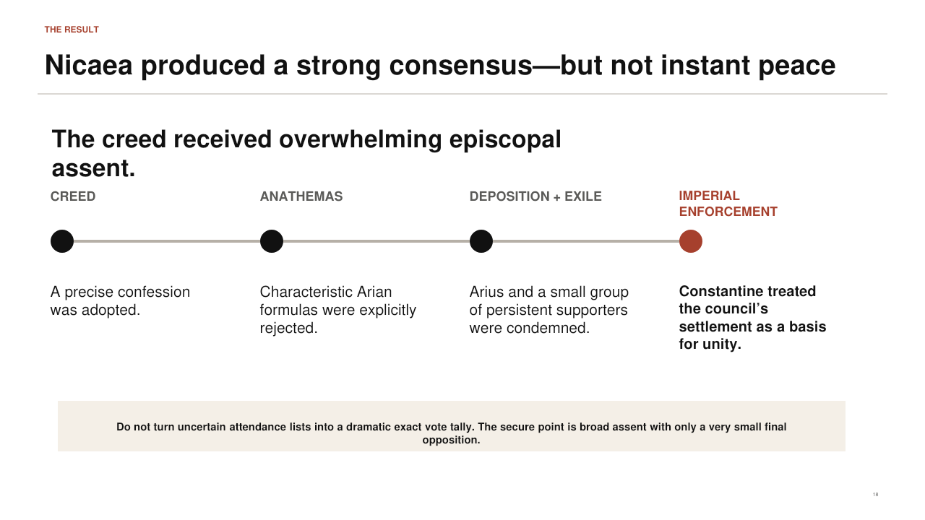
PowerPoint slide 18
CORE CLAIM The creed won overwhelming final assent and condemned Arius's formulas, yet political and theological conflict resumed almost immediately.

Historical Background
Most participating bishops signed the creed. Arius and a small group of persistent supporters were condemned, and Constantine used exile and other imperial measures to enforce the settlement. The council's doctrinal decision was therefore neither a narrow tie nor a merely private opinion. Nevertheless, consensus at the meeting did not settle how homoousios should be interpreted, whether deposed figures should be restored, how personal accusations against bishops should be judged, or which emperor would support which coalition in later years.

Suggested Presentation Narrative
Move through creed, anathemas, deposition and exile, and imperial enforcement. Explain that these are different actions: a positive confession, rejection of contrary formulas, ecclesiastical discipline, and civil enforcement. Then pause at the bottom warning. Popular numbers such as 318 versus 2 make the event memorable, but they pretend to a precision the sources do not securely supply. The historically responsible conclusion is broad or overwhelming assent with only a very small final opposition. Finish by reminding the audience that institutional assent and settled interpretation are not the same thing.
Accuracy guardrail. Avoid exact vote totals unless you explicitly label them as later traditional reconstructions rather than a surviving official tally.
Transition. The decades after 325 show how quickly the council's wording became entangled with changing alliances and imperial politics.
SLIDE 19

Nicaea's Unfinished Aftermath
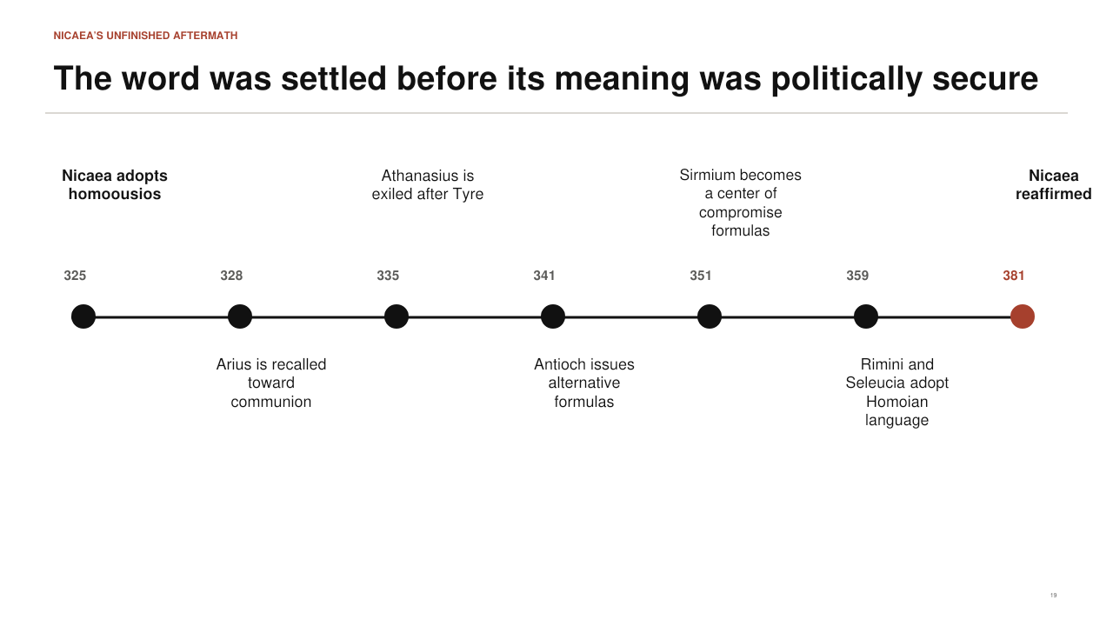
PowerPoint slide 19
CORE CLAIM The council fixed a doctrinal boundary in 325, but the political security and conceptual explanation of that boundary took more than fifty years.

Historical Background
Constantine soon favored reconciliation with some previously condemned eastern bishops, and Arius was considered for restoration to communion. Athanasius, bishop of Alexandria from 328, was exiled after the Council of Tyre in 335 amid disciplinary and political charges. Councils at Antioch offered formulas that could sound anti-Arian while avoiding homoousios. Sirmium became associated with several attempts at compromise. In 359, the twin councils of Rimini and Seleucia advanced Homoian language that said the Son was like the Father according to Scripture while avoiding essence terminology. The Nicene trajectory was consolidated at Constantinople in 381.

Suggested Presentation Narrative
Use the timeline to dismantle the idea that Nicaea ended Arianism overnight. Explain that some bishops rejected Arius's most radical language but also distrusted homoousios. Others accepted Nicaea but disagreed over its correct interpretation. Emperors convened councils, exiled bishops, restored them, and promoted different formulas. The result was not a straight line but a contested process. Highlight 325 and 381 as bookends: the first gives the decisive boundary; the second represents the durable pro-Nicene settlement.
Accuracy guardrail. Do not describe every alternative creed between 325 and 381 as simply "Arian." Many were anti-Arian in intention while also non-Nicene in vocabulary.
Transition. To understand the middle decades, replace the simple two-party picture with several theological coalitions.
SLIDE 20

The Post-Nicene Conflict Contained Several Rival Coalitions
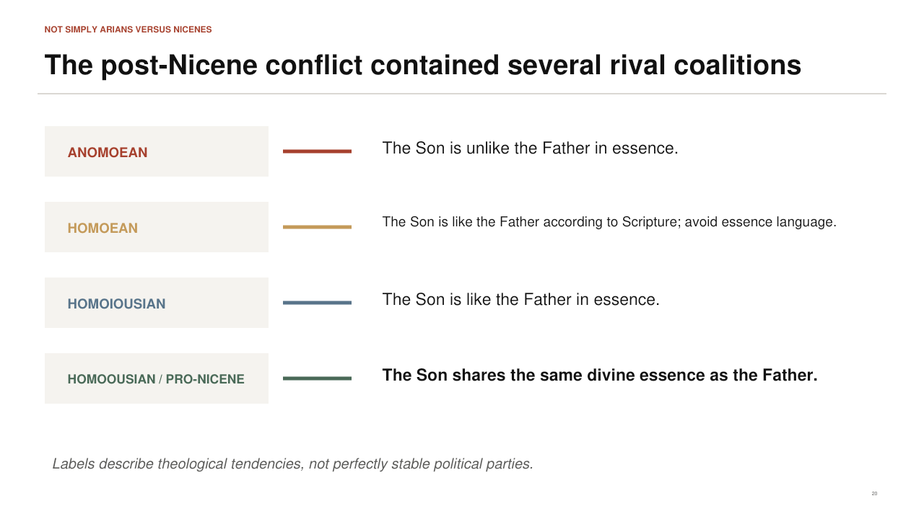
PowerPoint slide 20
CORE CLAIM The later fourth century included Anomoean, Homoean, Homoiousian, and Homoousian tendencies, not one uniform Arian party opposed to one unchanged Nicene party.

Historical Background
Anomoeans taught that the Son is unlike the Father in essence and emphasized the knowability of the unbegotten God. Homoeans preferred to say that the Son is like the Father "according to the Scriptures" while avoiding ousia language. Homoiousians confessed that the Son is like the Father in essence and often opposed the stronger subordinationism of Anomoeans. Homoousians or pro-Nicenes defended the Son's same essence with the Father. These labels help, but real bishops, councils, and formulas do not always fit cleanly into one permanent box.

Suggested Presentation Narrative
Pronounce the terms carefully and emphasize the vowels: anomoios means unlike; homoios means like; homoiousios means like in essence; homoousios means same in essence. Explain why the famous "one iota" comparison is memorable but inadequate. The dispute was not an accidental spelling contest. Each term carried a different judgment about God's being, biblical language, and personal distinction. Also explain that alliances changed and that the word Arian is often applied too broadly to everyone who opposed or avoided Nicaea.
Accuracy guardrail. Treat the categories as analytical aids, not stable denominations with membership cards and uniform confessions.
Transition. Athanasius became the best-known defender of Nicaea during these unstable decades.
SLIDE 21

The Defender of Nicaea Spent Years Outside His Own See
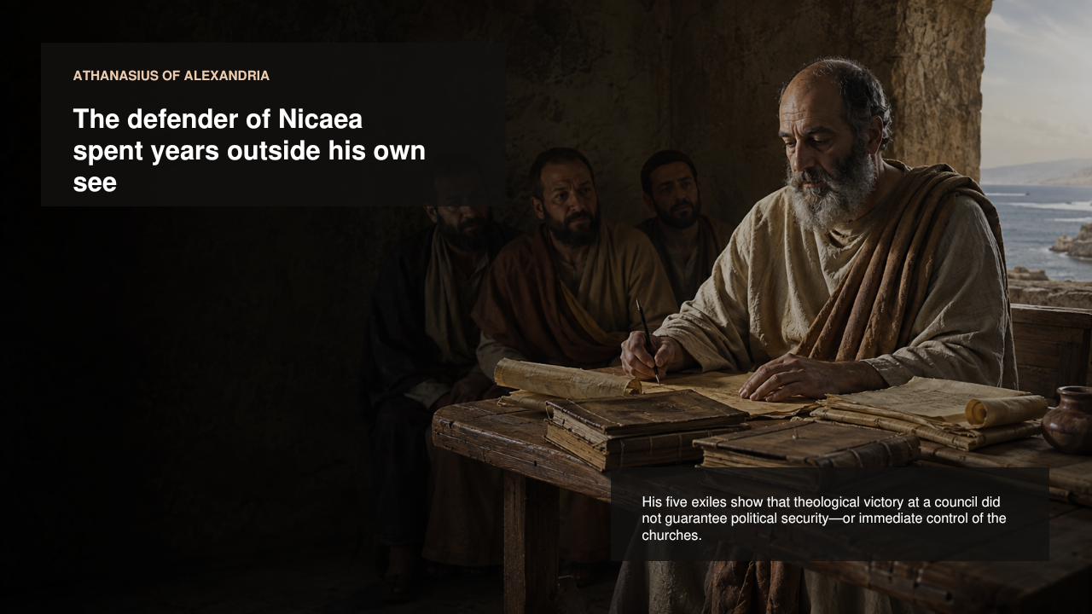
PowerPoint slide 21
CORE CLAIM Athanasius's five exiles reveal the interdependence of theology, episcopal rivalry, local conflict, synods, and imperial power.

Historical Background
Athanasius succeeded Alexander as bishop of Alexandria in 328. He defended the Nicene confession in works such as On the Decrees and the Orations Against the Arians, but he was also a forceful ecclesiastical leader involved in bitter disputes. Between 335 and 366 he experienced five exiles under different emperors. Charges against him included violence, administrative misconduct, and defiance of imperial or synodal decisions; his supporters regarded many proceedings as politically manipulated. Exile took him to places including Trier, Rome, and the Egyptian desert.

Suggested Presentation Narrative
Use the image to show both intellectual and political endurance. Avoid presenting Athanasius as a solitary theologian who simply won an argument by writing books. He cultivated alliances, appealed to western bishops, defended his episcopal legitimacy, and interpreted exile as part of faithfulness. His career shows that a council's theological decision did not automatically control imperial appointments or local churches. Give him credit as a profound theologian while acknowledging that ancient church politics were personal, procedural, and sometimes coercive.
Accuracy guardrail. Do not use the later phrase "Athanasius against the world" as a literal claim that he alone held Nicene faith or that every charge against him was purely doctrinal.
Transition. Now summarize the theological argument that made Athanasius so influential.
SLIDE 22

Athanasius Argued from Creation, Worship, and Salvation
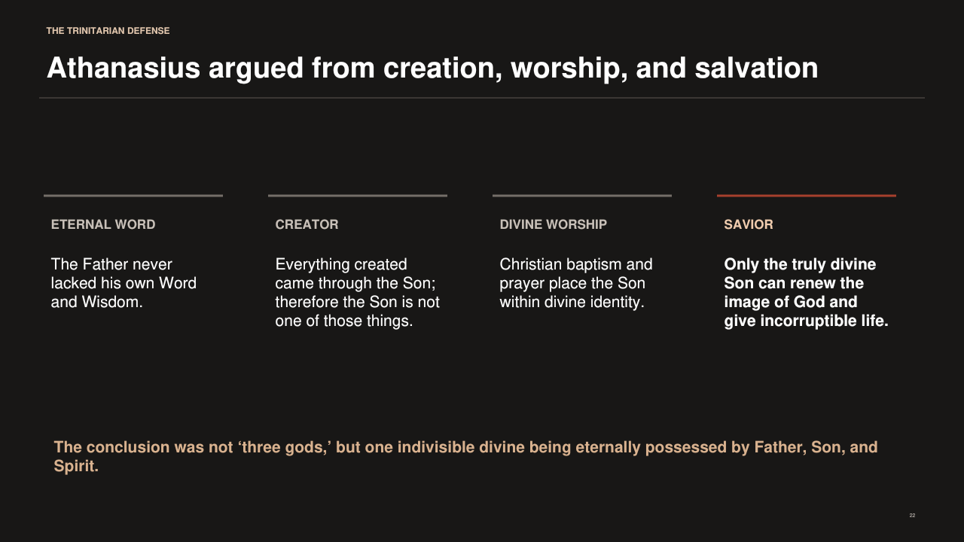
PowerPoint slide 22
CORE CLAIM The eternal Word is not a creature who receives divine gifts; he is the Creator and Savior who gives life, grace, and restoration.

Historical Background
Athanasius argued that the Father was never without his Word and Wisdom. If God is eternally Father, the Son is not a later product. Because all created things came through the Word, the Word cannot be numbered among them. Because Christians worship and are baptized in relation to the Son with the Father, the Son cannot be a creature without compromising monotheism. In the incarnation, the Word assumes a true human body and restores the image of God, defeats corruption and death, and makes human participation in divine life possible.

Suggested Presentation Narrative
Walk across the four headings as one chain. Eternal Word means the Father did not first exist as a solitary God and later decide to produce a Son. Creator means the Son is outside the class of created realities. Divine worship means Christian practice identifies the Son with God rather than an exalted angel. Savior means the Word possesses in himself the life he communicates. Use Athanasius's concise logic: creatures are recipients of grace; the Son is its giver. The conclusion is one divine being, not two or three gods.
Accuracy guardrail. Athanasius's mature arguments developed across decades. Do not read every later pro-Nicene distinction back into the earliest stage of the conflict without qualification.
Transition. Theological durability mattered, but emperors still possessed the power to convene synods, enforce formulas, and remove bishops.
SLIDE 23

Emperors Could Exile Bishops - but Not Settle Theology Permanently
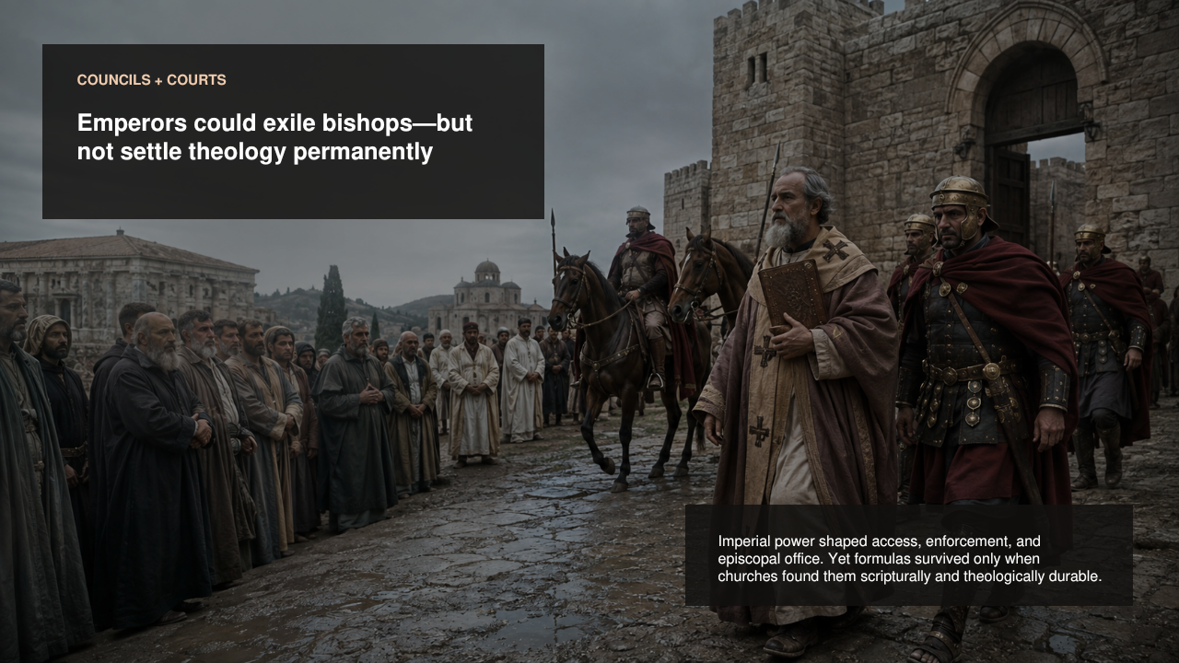
PowerPoint slide 23
CORE CLAIM Imperial power decisively shaped office, travel, councils, and enforcement, yet a formula endured only when churches could receive and defend it as faithful to Scripture and worship.

Historical Background
Fourth-century emperors regarded church unity as part of public order. They summoned councils, paid travel expenses, confirmed decisions, banished bishops, recalled exiles, and sometimes pressured assemblies toward preferred formulas. Constantius II strongly supported non-Nicene settlements; Julian allowed exiled bishops to return partly to unsettle the church; Valens favored Homoean leaders in the East; Theodosius I supported the pro-Nicene settlement. These interventions changed who occupied sees and which councils could meet, but they did not create automatic, permanent theological agreement.

Suggested Presentation Narrative
Distinguish influence from invention. Imperial power could make a theological position institutionally dominant for a time by controlling bishops and councils. It could not by decree make an unstable formula intellectually coherent or universally accepted. The image of exile shows the cost of disagreement, while the final sentence explains the limit of coercion. This balance also helps answer claims that Constantine simply chose the Trinity. If imperial preference alone settled doctrine, the repeated reversals after Constantine would have produced a different permanent result.
Accuracy guardrail. Do not romanticize the process as free debate untouched by power. Exile, patronage, access to councils, and control of churches materially affected theological history.
Transition. The Cappadocian Fathers helped provide the conceptual language that made the pro-Nicene position more stable.
SLIDE 24

One Ousia - Three Hypostases
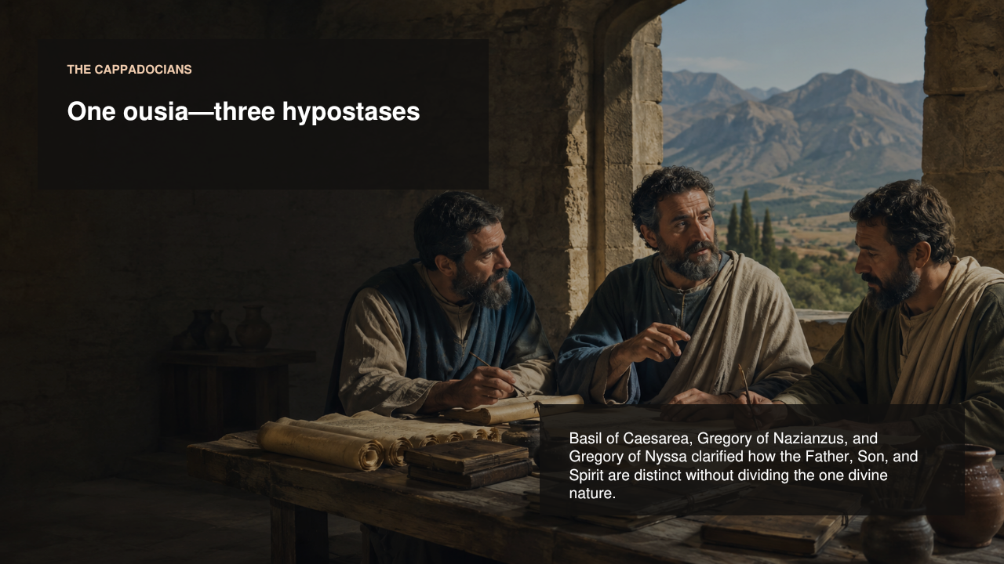
PowerPoint slide 24
CORE CLAIM The Cappadocians clarified that the one divine essence is fully and indivisibly possessed by three irreducible hypostases: Father, Son, and Holy Spirit.

Historical Background
Basil of Caesarea, Gregory of Nazianzus, and Gregory of Nyssa wrote in the later fourth century as terminology was becoming more precise. Ousia came to name the common divine essence or nature; hypostasis named the concrete personal distinction of Father, Son, and Spirit. The formula guarded against tritheism by confessing one undivided divine nature and activity, and against modalism by refusing to make the three mere names or temporary appearances of one person. The Cappadocians also contributed decisively to the defense of the Holy Spirit's divinity.

Suggested Presentation Narrative
Define the Greek words without suggesting they map perfectly onto modern English. Ousia answers, "What is God?" Hypostasis answers, "Who is the Father, Son, or Spirit?" There is one what and three whos - but warn that even this teaching shorthand is not a complete metaphysical explanation. Emphasize relations: the Father is unbegotten, the Son begotten, and the Spirit proceeds. These distinctions do not divide the divine nature into thirds. Each is fully God, and the divine action is inseparable.
Accuracy guardrail. Do not say that the Cappadocians invented three persons after Nicaea. They refined terminology for distinctions already present in Scripture, worship, and earlier theology.
Transition. This clarified grammar formed the background for the Council of Constantinople in 381.
SLIDE 25

The Nicene Trajectory Became the Church's Durable Confession
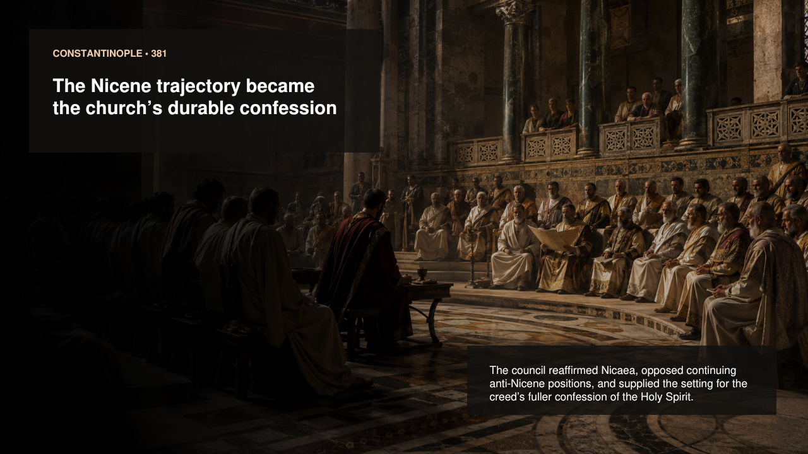
PowerPoint slide 25
CORE CLAIM Constantinople in 381 reaffirmed Nicaea, opposed continuing anti-Nicene positions, and marked the consolidation of a fuller Trinitarian settlement.

Historical Background
Emperor Theodosius I convened the Council of Constantinople in 381. It was primarily an eastern council, later received as the second ecumenical council. It affirmed the faith of Nicaea, condemned several opposing groups, and addressed ecclesiastical order. The creed commonly called Niceno-Constantinopolitan gives a fuller confession of the Holy Spirit as Lord and life-giver, proceeding from the Father, worshiped and glorified with Father and Son. The precise textual relationship between the council and the creed's surviving form is historically complex, but 381 stands as the decisive consolidation of pro-Nicene orthodoxy.

Suggested Presentation Narrative
Explain continuity and development. Constantinople did not discard Nicaea. It received its trajectory and articulated more fully what the church confessed about the Holy Spirit. Mention that the council was not initially a perfectly representative worldwide gathering in the modern sense; its ecumenical authority developed through reception. Under Theodosius, pro-Nicene bishops gained decisive institutional support. Yet the lasting confession was more than imperial policy: it integrated Scripture, worship, salvation, and the clarified language of one essence and three hypostases.
Accuracy guardrail. Do not claim that historians possess a simple verbatim record proving that every line of the later creed was newly composed on the council floor in 381.
Transition. Close by gathering the scriptural, conciliar, soteriological, and Trinitarian strands into one conclusion.
SLIDE 26

The Defense Protected God's Identity and the Reality of Salvation
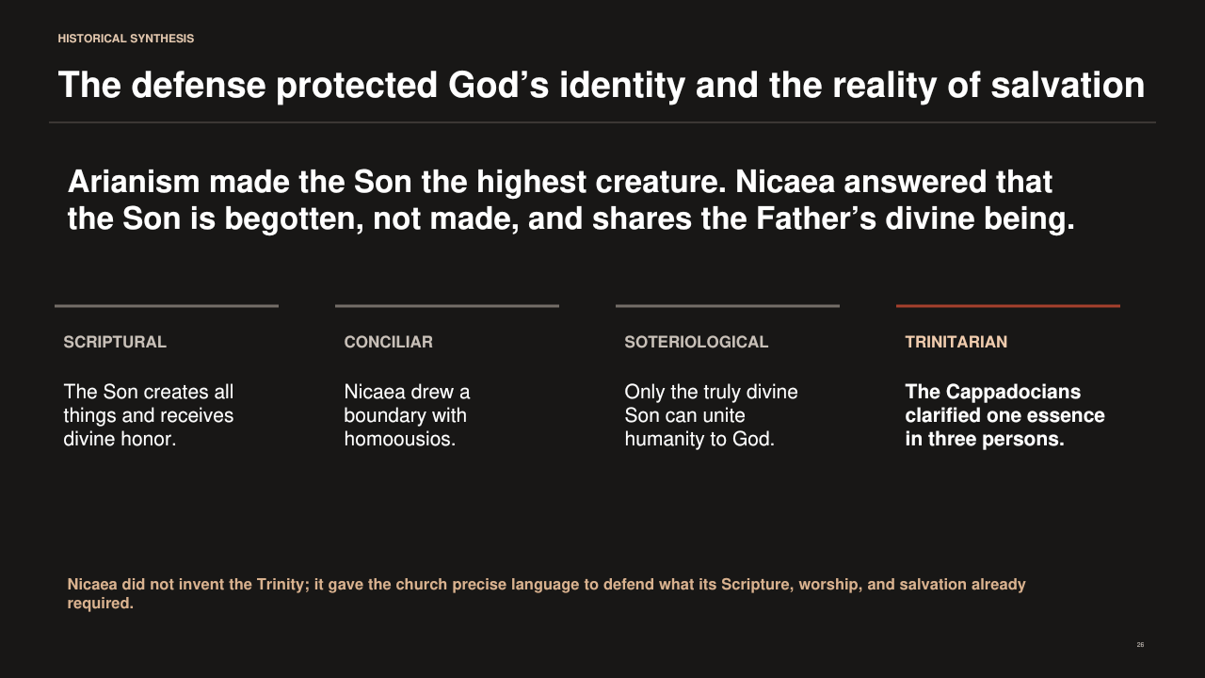
PowerPoint slide 26
CORE CLAIM The pro-Nicene settlement confessed the Son as eternally within the one divine being because Christian Scripture, worship, creation, and salvation required more than a highest creature.

Historical Background
Arius offered a coherent hierarchy: one unbegotten Father, a uniquely generated Son, and a world created through that Son. Nicaea rejected the placement of the Son among created realities by confessing him as true God, begotten not made, and homoousios with the Father. Athanasius emphasized that only the divine Word can create and restore humanity. The Cappadocians clarified one ousia and three hypostases, including a fuller defense of the Holy Spirit. Constantinople in 381 marked the durable conciliar consolidation of this trajectory.

Suggested Presentation Narrative
Return to the four words on the slide. Scriptural: the Son creates all things and receives divine honor. Conciliar: Nicaea gave the church a public boundary. Soteriological: only the divine Son can communicate divine life. Trinitarian: the one God eternally exists as Father, Son, and Holy Spirit. Finish with the slide's final sentence: Nicaea did not invent the Trinity. It gave precise anti-Arian language to defend what pro-Nicenes believed Scripture, worship, and salvation already required. Invite questions by distinguishing historical claims from confessional judgments.
Accuracy guardrail. Avoid a triumphalist ending that erases coercion, ambiguity, regional diversity, or the long process of reception. The theological synthesis emerged through both argument and contested institutions.
Transition. End the presentation here, then use the discussion questions in this guide to reinforce the central distinctions.

Questions You Should Be Ready to Answer

Did Arius teach that Jesus was only a human being?
No. Arius taught a preexistent, unique Son through whom the Father created the world. The Son was nevertheless originated by the Father and did not share the same uncreated divine essence.

Did Constantine invent the Trinity at Nicaea?
No. Trinitarian worship, scriptural argument, and controversies over Father and Son predated Constantine. Constantine convened and enforced the council because he wanted unity; bishops formulated the creed in response to an existing church dispute.

Did Nicaea choose the books of the Bible?
No. The surviving creed, anathemas, synodal letter, and twenty canons contain no canon-of-Scripture decision.

Was Nicaea a close vote?
The secure conclusion is overwhelming final assent with a very small opposition. Exact attendance and vote totals vary in the sources and should not be presented as certain.

What does homoousios mean?
It means "of the same essence" or "of one being." It confesses that the Son possesses the same divine nature as the Father while remaining personally distinct as Son.

Did Saint Nicholas punch Arius?
The story is a late medieval tradition absent from contemporary Nicene records. The earliest located version speaks of "a certain Arian," and Nicholas's attendance is itself uncertain.

Did Nicaea end Arianism?
No. Rival councils, exiles, imperial reversals, and alternative formulas continued for more than fifty years. Constantinople in 381 marks the durable consolidation of the pro-Nicene trajectory.

Why did salvation matter to the argument?
Pro-Nicenes argued that creatures receive grace and divine life, whereas the Son gives them. Only the truly divine Word can unite humanity to God and restore the divine image.

Compact Glossary
Arianism. A label for theology that places the Son below the Father in divine being; it is often used too broadly for several distinct fourth-century positions.
Begotten. Language of the Son's relation of origin from the Father. Nicaea contrasts eternal generation with being made as a creature.
Ecumenical council. A council received as representing and binding the universal church; the exact institutional account differs among Christian traditions.
Homoousios. Of the same essence or being; the Nicene boundary term for the Son's full deity.
Homoiousios. Like in essence; associated with a later coalition that opposed both Anomoeanism and Nicene same-essence language.
Hypostasis. In mature pro-Nicene usage, the concrete personal reality of Father, Son, or Spirit.
Ousia. Essence, being, or nature; in mature pro-Nicene usage, the one undivided divine nature.
Pro-Nicene. A useful historical term for the developing coalition and theology that received and interpreted Nicaea as confessing the Son's full and eternal deity.

Primary Sources and Further Study
Arius, Letter to Eusebius of Nicomedia. A short primary witness to Arius's claim that the Son existed before the ages by the Father's will while not being unbegotten.
Eusebius of Caesarea, Letter to the Church of Caesarea. A participant's explanation of the creed and his own acceptance of its disputed expressions.
The Creed, Anathemas, and Canons of Nicaea (325). The council's central doctrinal and disciplinary texts.
Athanasius, Orations Against the Arians and On the Decrees of Nicaea. Major pro-Nicene arguments from Scripture, creation, divine generation, and salvation.
Socrates Scholasticus, Church History, Book 1 and following. A fifth-century narrative preserving documents and accounts of the controversy and its political aftermath.
Basil of Caesarea, Letter 236. A useful witness to the distinction between ousia and hypostasis.
Gregory of Nazianzus, Theological Orations. A mature pro-Nicene exposition of Father, Son, and Holy Spirit.
Lewis Ayres, Nicaea and Its Legacy. A major modern scholarly study of the diverse theological movements and the formation of pro-Nicene theology.
R. P. C. Hanson, The Search for the Christian Doctrine of God. A detailed modern history of the Arian controversy from 318 to 381.

Online Texts Used in the Presentation
https://www.fourthcentury.com/urkunde-1/
https://www.fourthcentury.com/urkunde-22/
https://www.fourthcentury.com/nicaea-325-canons/
https://www.newadvent.org/fathers/3801.htm
https://www.newadvent.org/fathers/2812.htm
https://www.newadvent.org/fathers/26011.htm
https://www.newadvent.org/fathers/3202236.htm
https://www.newadvent.org/fathers/310231.htm
https://www.roger-pearse.com/weblog/2015/02/28/did-st-nicholas-of-myra-santa-claus-punch-arius-at-the-council-of-nicaea/

