CHURCH HISTORY TEACHING GUIDE
The Great Persecution
Diocletian, the Tetrarchy, and the Campaign Against Christians
A slide-by-slide presenter’s study guide for the 26-slide visual history
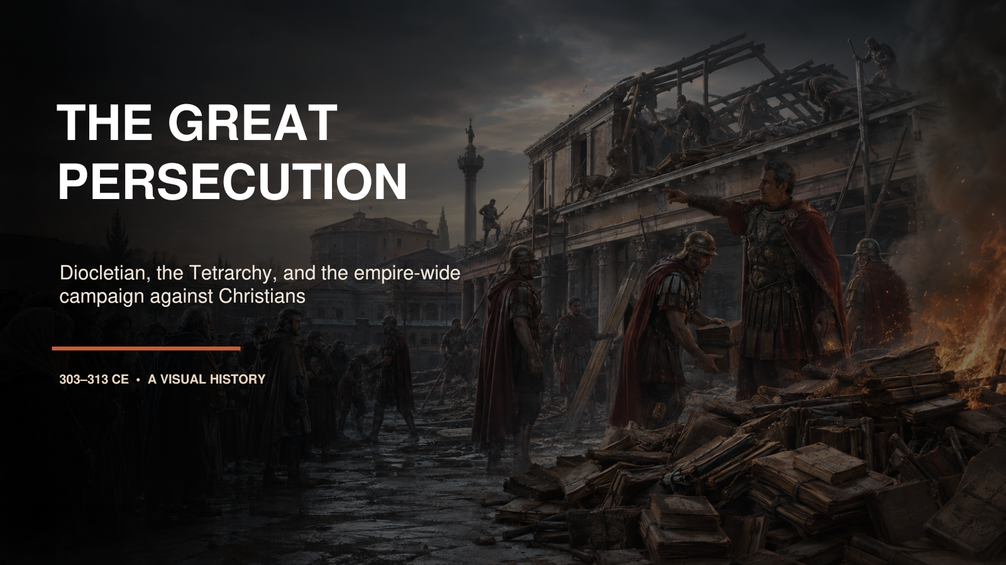
Prepared for teaching, review, and historical discussion

How to Use This Guide
This guide is designed to help you understand the material well enough to teach it in your own words. It does not require you to read every paragraph aloud. Study the historical background first, then use the suggested narrative as a speaking model. The accuracy guardrails identify claims that are commonly overstated or confused.
Recommended pacing. A full presentation will normally require 50–65 minutes. Allow about two minutes for most slides, three minutes for the edict sequence and regional comparison, and four to six minutes for the four map slides. For a 35-minute version, move quickly through Slides 4, 9, 14, and 16 and summarize Slides 23–26 as one regional unit.
Teaching approach. Lead with the central claim printed at the start of each slide section. Explain the background in plain language, refer to the visual, then use the transition sentence to carry the audience forward. The narrative should feel cumulative: Roman government created the policy, regional rulers shaped it, Christians responded, and political collapse reversed it.
Pronunciation. Diocletian: dye-uh-KLEE-shun. Galerius: guh-LAIR-ee-us. Nicomedia: nick-uh-MEE-dee-uh. Constantius: con-STAN-shee-us. Maximian: mak-SIM-ee-un. Maximinus Daia: mak-SIM-ih-nus DAY-uh. Caesarea: sess-uh-REE-uh. Abitinae: ab-ih-TEE-nee. traditor: TRAD-ih-tor. lapsi: LAP-see.

The Story in Seven Movements
1. Setting Slides 1–5: define the Great Persecution, the Tetrarchy, Christian growth, and the Roman logic of sacrifice.
2. Escalation Slides 6–10: Nicomedia, the four edicts, bureaucratic enforcement, palace-fire caution, and the sacrifice tribunal.
3. Regional variation Slides 11–12: compare the restrained far West with the sustained eastern campaign.
4. Christian experience Slides 13–16: hidden worship, documented cases, the mines, and the spectrum of response.
5. Ecclesial aftermath Slide 17: traditores, the lapsed, sacramental legitimacy, and Donatism.
6. Political reversal Slides 18–22: the collapse of the Tetrarchy, Galerius’s toleration, the 313 settlement, and the synthesis.
7. Geography Slides 23–26: locate the narrative across the Roman Empire and explain the major regional attack zones.

SLIDE 01

The Great Persecution
PowerPoint slide 1
CORE CLAIM The “Great Persecution” was the Roman Empire’s final and most systematic attempt to suppress Christianity, but it was not equally severe in every place or year.

Historical Background
The campaign normally called the Diocletianic or Great Persecution began in 303 CE and ended in stages between 311 and 313. Diocletian gave the persecution its name because he was the senior emperor when it began, but four rulers and several successors shaped what happened. The policy attacked Christian buildings, books, legal rights, clergy, worship, and eventually the refusal to sacrifice. It therefore reached far beyond isolated executions. It attempted to dismantle Christianity as an organized public community.

Suggested Presentation Narrative
Open with the picture rather than a list of dates. Ask the audience to imagine watching soldiers demolish a church, carry out the congregation’s books, and burn them under an imperial order. Explain that Christianity had already become visible enough to possess buildings, property, recognized leaders, and members in government and the army. The persecution was an attempt to reverse that growth. Tell the class that the presentation will answer four questions: Who ordered it? How did it work? Why did it vary geographically? Why did it fail?
Accuracy guardrail. Do not describe 303–313 as ten years of constant empire-wide mass execution. The laws, enforcement, and political authorities changed repeatedly.
Transition. To understand the persecution, we must first abandon the idea that it was one uniform wave of violence.

SLIDE 02

It Was Not One Uninterrupted Wave of Killing
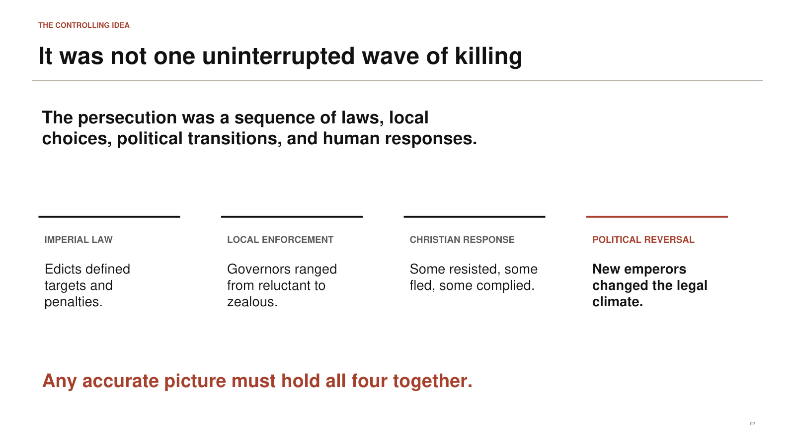
PowerPoint slide 2
CORE CLAIM An accurate explanation must combine imperial law, local enforcement, Christian response, and political change.

Historical Background
Imperial edicts created the legal framework, but governors, city councils, soldiers, prison officials, and local communities determined how that framework operated on the ground. A law could remain technically valid while being weakly enforced in one province and aggressively expanded in another. Christians also responded differently. Some confessed openly, some fled, some hid books, some negotiated, and some complied with sacrifice or surrendered property. Meanwhile, emperors died, abdicated, fought civil wars, and replaced one another.

Suggested Presentation Narrative
Use the four headings on the slide as the interpretive grid for the whole presentation. First, ask what the law actually ordered. Second, ask who enforced it and how zealously. Third, ask what choices Christians made. Fourth, ask what changed politically. Explain that a martyr account usually magnifies one dramatic trial, whereas a papyrus inventory may reveal confiscation as ordinary administration. Both are real parts of the story, but neither alone gives the full picture.
Accuracy guardrail. Avoid using the number of surviving martyr stories as if it were a reliable provincial death rate. Survival of evidence is uneven.
Transition. The first source of variation was built into the Roman government itself: four emperors shared authority.

SLIDE 03

Four Rulers Governed One Empire
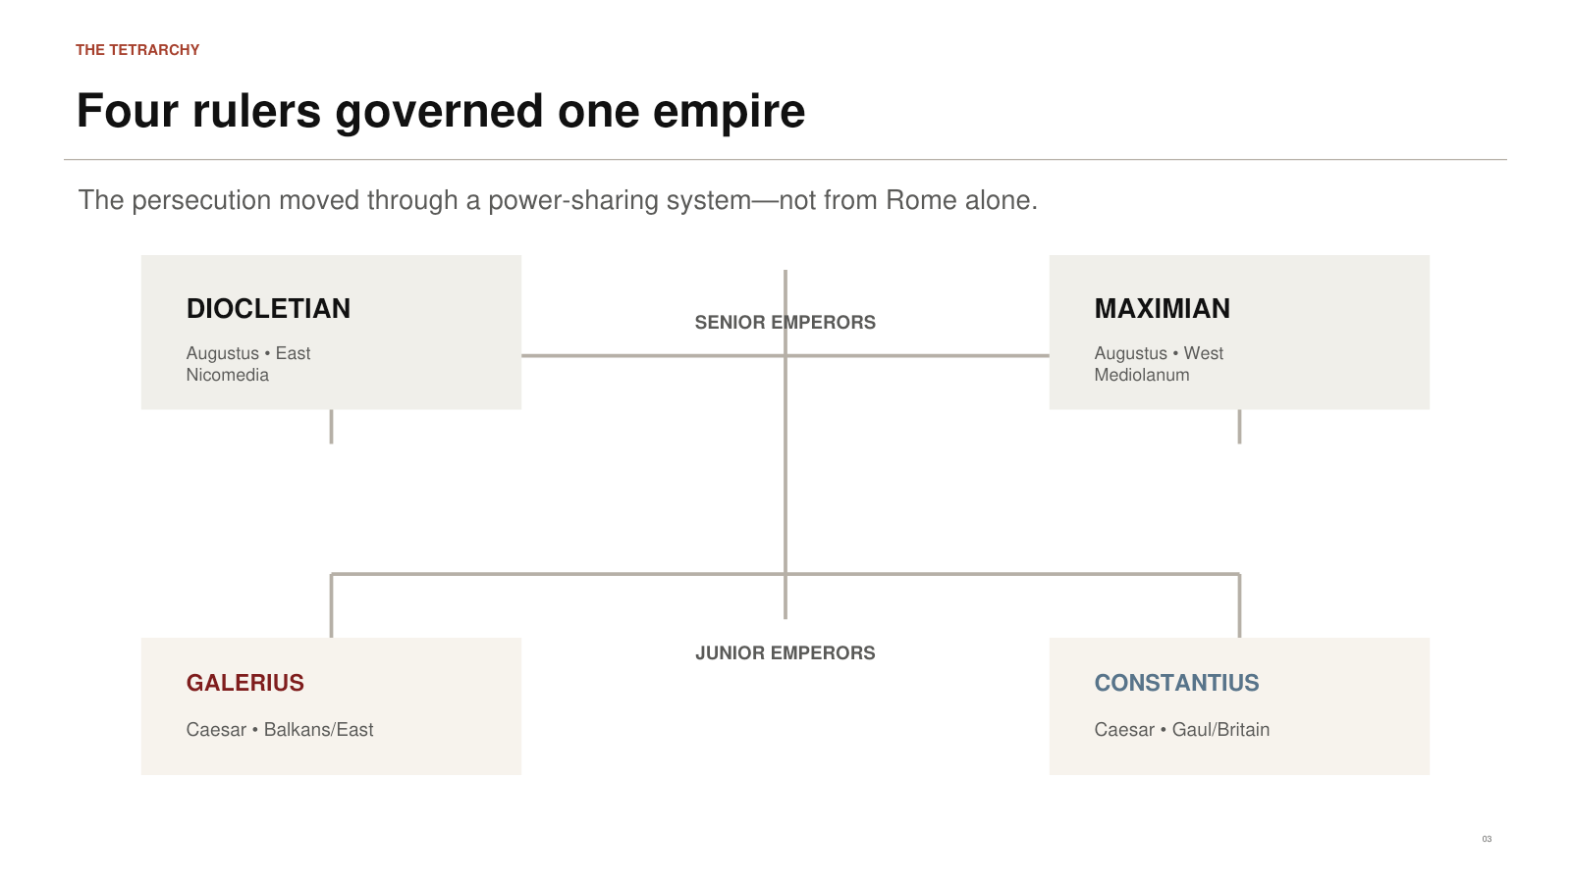
PowerPoint slide 3
CORE CLAIM The Tetrarchy divided practical government among two senior Augusti and two junior Caesars.

Historical Background
Diocletian reorganized imperial rule because one emperor could not easily govern and defend the whole Roman world. Diocletian and Maximian served as Augusti, the senior emperors. Galerius and Constantius served as Caesars, junior emperors intended to assist and eventually succeed them. Each ruler operated from strategic imperial residences rather than treating Rome as the sole administrative center. Diocletian was associated especially with Nicomedia, Maximian with Mediolanum, Galerius with the Balkans and eastern military sphere, and Constantius with Gaul and Britain.

Suggested Presentation Narrative
Point to the diagram and explain that the empire remained one political ideal, but government was distributed. This matters because religious enforcement often followed the ruler. Constantius was comparatively restrained. Galerius became closely associated in Christian sources with escalation. Maximian enforced the policy seriously in Italy and Africa. Diocletian stood at the top of the system when the first edict was issued. After 305, the personnel changed, but the laws did not automatically disappear.
Accuracy guardrail. Do not call the four zones four independent countries. The Tetrarchy was a power-sharing arrangement within one Roman Empire.
Transition. Before this four-man government turned against Christianity, the churches had experienced decades of relative security and expansion.

SLIDE 04

The Church Entered 303 After Decades of Growth
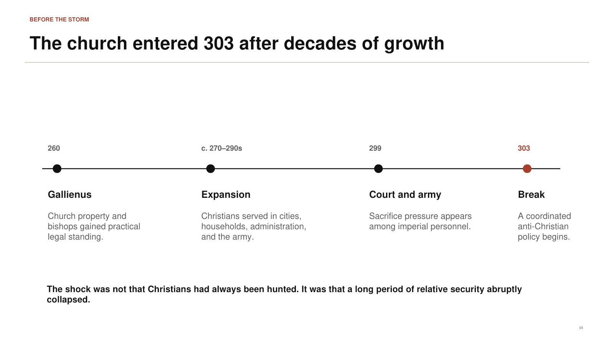
PowerPoint slide 4
CORE CLAIM The persecution struck a church that had become socially visible, institutionally organized, and materially established.

Historical Background
After Emperor Gallienus ended the Valerian persecution in 260, Christians experienced a long period of relative peace. Bishops and congregations possessed property; Christians served in households, administration, commerce, and the military; and some communities constructed identifiable meeting buildings. This did not mean Christianity enjoyed modern religious liberty. It meant that the empire often tolerated a movement that had become difficult to treat as a small, hidden sect.

Suggested Presentation Narrative
Emphasize the contrast. The Great Persecution did not begin because Christians suddenly appeared in 303. It began after Christian life had become visible and embedded. That visibility explains why the first edict focused so heavily on institutions: buildings could be demolished, books could be confiscated, officeholders could be degraded, and assemblies could be forbidden. The state was attacking a public network. That is why the opening of the persecution felt like a dramatic reversal.
Accuracy guardrail. “Relative peace” does not mean the absence of every local conflict or legal vulnerability. It describes the broad imperial situation between major persecutions.
Transition. The next question is why Christian visibility came to be interpreted as a threat to imperial order.

SLIDE 05

Imperial Unity Made Christian Refusal Look Political
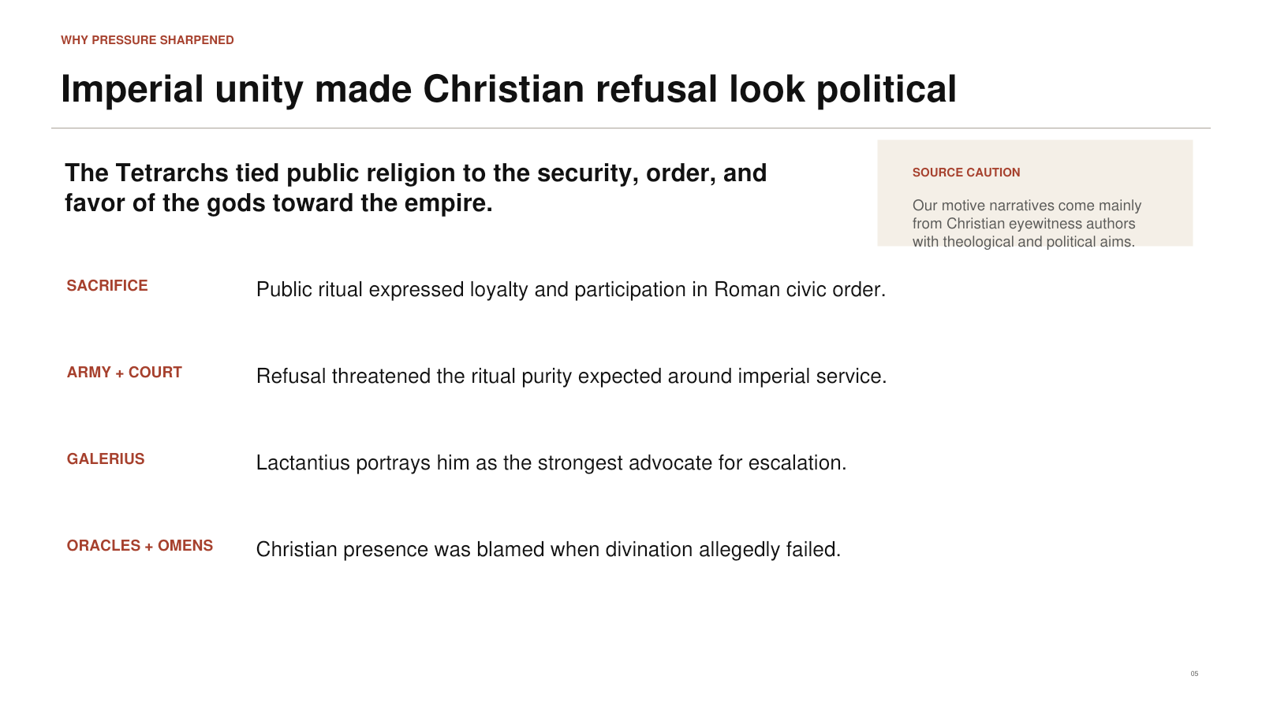
PowerPoint slide 5
CORE CLAIM Roman authorities connected public sacrifice with loyalty, social order, and the favor of the gods.

Historical Background
Roman religion was deeply public. Sacrifices, festivals, military ritual, and honor toward the emperors were woven into civic life. Many Romans could participate in several cults without treating them as mutually exclusive. Christians, however, confessed one God and rejected sacrifice to other gods. Their refusal could therefore appear stubborn, antisocial, or dangerous—especially when rulers believed proper ritual secured divine favor for the empire. Lactantius reports that Christian presence was blamed when divination failed and portrays Galerius as pressing Diocletian toward harsher measures.

Suggested Presentation Narrative
Explain that Roman officials did not ordinarily ask whether a person privately admired Jesus. They demanded a public act. A small amount of incense or wine could signal participation in the religious order of the empire. Christians understood that act as worship and therefore as betrayal of Christ. The collision was between two different understandings of loyalty. Also explain that our account of the imperial debate comes mainly through Christian authors who interpreted the conflict theologically.
Accuracy guardrail. State Lactantius’s accusations as his report, not as independently proven access to every private imperial conversation.
Transition. That ideological conflict became concrete at Nicomedia in February 303.

SLIDE 06

The Church at Nicomedia Is Demolished
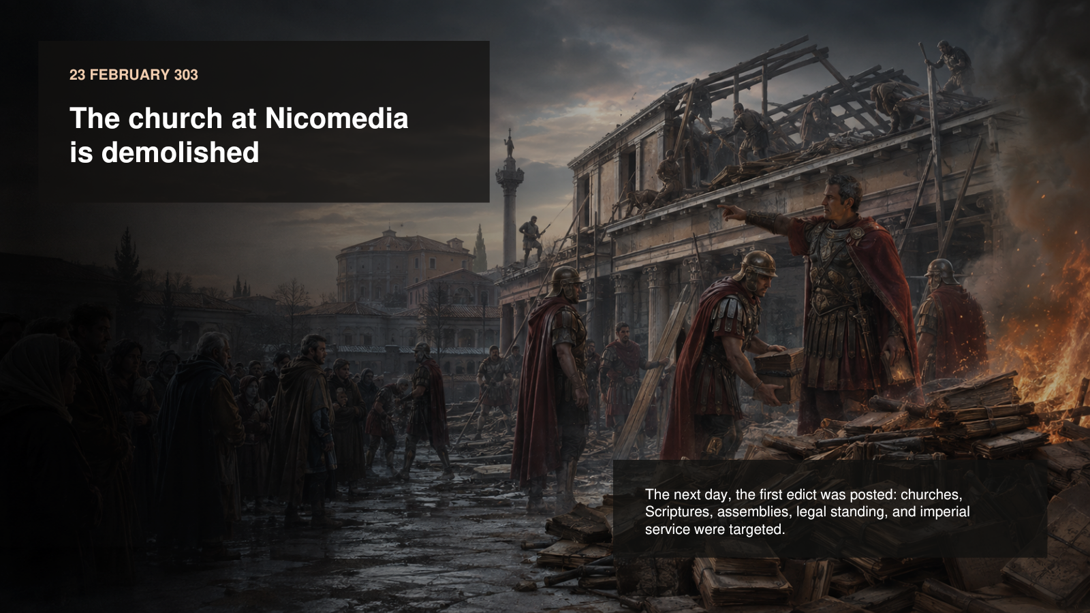
PowerPoint slide 6
CORE CLAIM The campaign opened symbolically by destroying a prominent Christian building near the imperial court.

Historical Background
Lactantius dates the demolition to 23 February 303, the Roman festival of the Terminalia. Soldiers and officials tore down the church at Nicomedia, seized its contents, and burned Christian books. The following day the first edict was published. Eusebius summarizes its provisions: churches were to be razed, Scriptures destroyed, Christians of rank deprived of legal privileges, and imperial household servants reduced in status if they persisted.

Suggested Presentation Narrative
Describe the scene carefully. The image is a reconstruction, but its central elements reflect the literary evidence: a church building, confiscated books, official action, and a watching public. Explain why books mattered. Christian identity depended on texts read publicly in worship, copied across congregations, and guarded by clergy and readers. Destroying Scriptures was an attempt to break memory, worship, and teaching at once.
Accuracy guardrail. The image should not be treated as an exact architectural portrait of the Nicomedia church. The reported event is historical; the visual details are interpretive.
Transition. The first edict was only the beginning. A sequence of measures turned institutional suppression into personal coercion.

SLIDE 07

Four Measures Turned Exclusion into Coercion
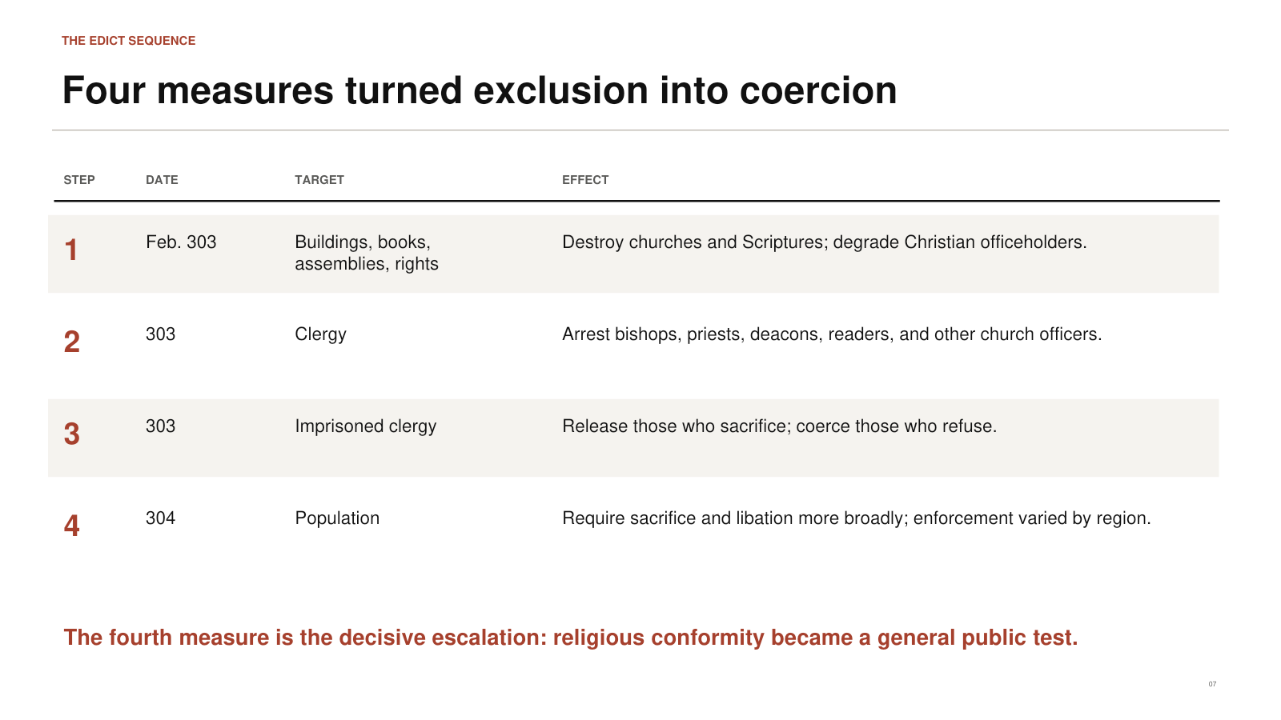
PowerPoint slide 7
CORE CLAIM The persecution escalated from property and status to clergy arrests and broad compulsory sacrifice.

Historical Background
The first edict attacked churches, books, assemblies, civil standing, and imperial employment. A second measure ordered the arrest of church leaders. A third offered release to imprisoned clergy who sacrificed and intensified coercion against those who refused. A fourth measure, commonly dated to early 304, required sacrifice more broadly among the population. Scholars reconstruct the sequence from Eusebius, Lactantius, martyr acts, and regional evidence because the complete original texts of all four measures do not survive.

Suggested Presentation Narrative
Walk through the progression slowly. The state first made organized Christianity legally and materially vulnerable. It then removed leadership. Next it used imprisonment to obtain religious compliance. Finally it turned sacrifice into a general public test. Emphasize that the fourth edict is the major escalation. At that point ordinary Christians—not only bishops or officials—could be summoned and forced to choose publicly.
Accuracy guardrail. The conventional four-edict outline is a historical reconstruction. Be confident about the broad sequence but cautious about claiming exact surviving wording for every stage.
Transition. Once issued, the edicts entered a bureaucratic machine that translated law into searches, inventories, trials, and punishments.

SLIDE 08

The State Attacked Institutions Before Bodies
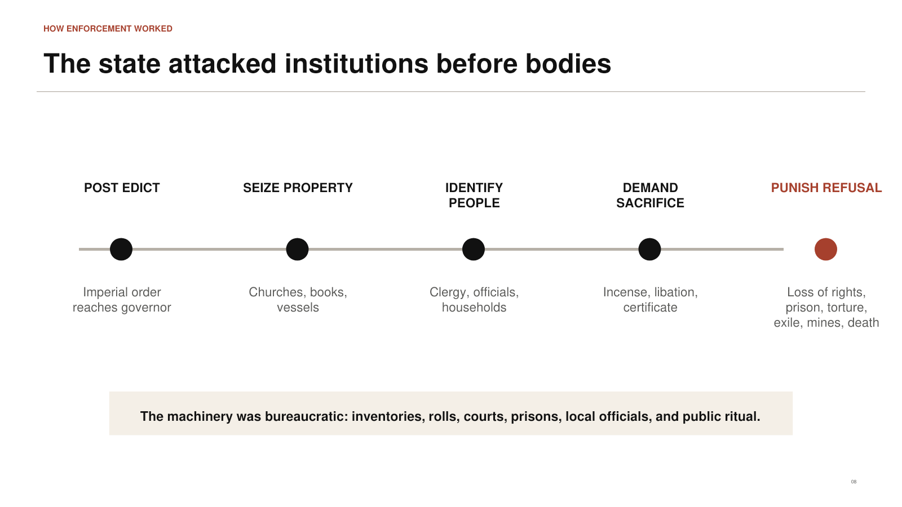
PowerPoint slide 8
CORE CLAIM The persecution operated through ordinary Roman administrative systems as well as spectacular violence.

Historical Background
Governors received imperial instructions. Local officials identified church property, searched for books, arrested clergy, used civic rolls, and convened tribunals. Prisons were not designed primarily as long-term punishment; they held accused persons before trial or coercion. Some were stripped of legal privileges, some tortured, some exiled, some sent to mines, and some executed. Documentary papyri show officials inventorying confiscated property with routine administrative language.

Suggested Presentation Narrative
Use the process diagram from left to right. The edict was posted; property was seized; people were identified; sacrifice was demanded; refusal produced consequences. Explain that “bureaucratic” does not mean mild. Bureaucracy made the campaign repeatable. It allowed violence to be organized through records, officials, courts, and property law rather than depending only on mobs or spontaneous hatred.
Accuracy guardrail. Do not assume every person passed through every step. The diagram explains the legal logic, not a mandatory sequence in every individual case.
Transition. Fear intensified at Nicomedia when fires struck the imperial palace—but this is also where careful source criticism becomes essential.

SLIDE 09

The Palace Fires Hardened Suspicion
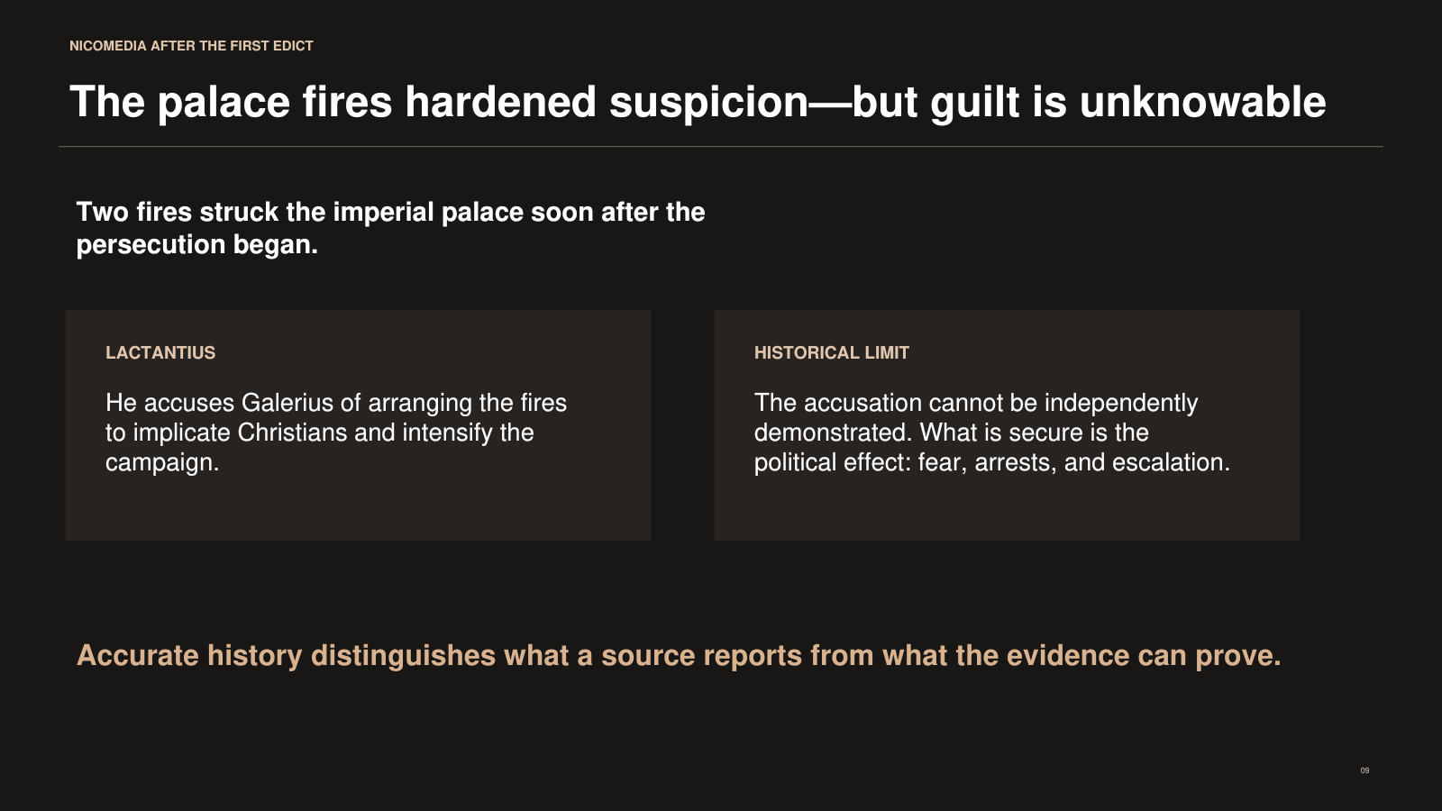
PowerPoint slide 9
CORE CLAIM The palace fires contributed to escalation, but the claim that Galerius arranged them cannot be proven.

Historical Background
Soon after the first edict, fires damaged the imperial palace at Nicomedia. Christians were suspected, and arrests and executions followed. Lactantius alleged that Galerius secretly caused the fires to frame Christians and force Diocletian into greater severity. That accusation fits Lactantius’s larger portrayal of persecuting emperors as wicked rulers judged by God. No independent source allows historians to establish Galerius’s guilt.

Suggested Presentation Narrative
This is an opportunity to model honest Christian history. Say plainly: “Lactantius reports an accusation; we do not possess enough evidence to turn it into a demonstrated fact.” Then explain what is historically secure: the fires occurred, suspicion fell on Christians, and the atmosphere became more dangerous. Distinguishing evidence from inference strengthens rather than weakens the presentation.
Accuracy guardrail. Never state, “Galerius burned the palace,” without the qualifier that this is Lactantius’s hostile allegation.
Transition. Whether accused after a crisis or summoned under an edict, Christians eventually faced the central public test: sacrifice.

SLIDE 10

A Pinch of Incense Could Decide a Life
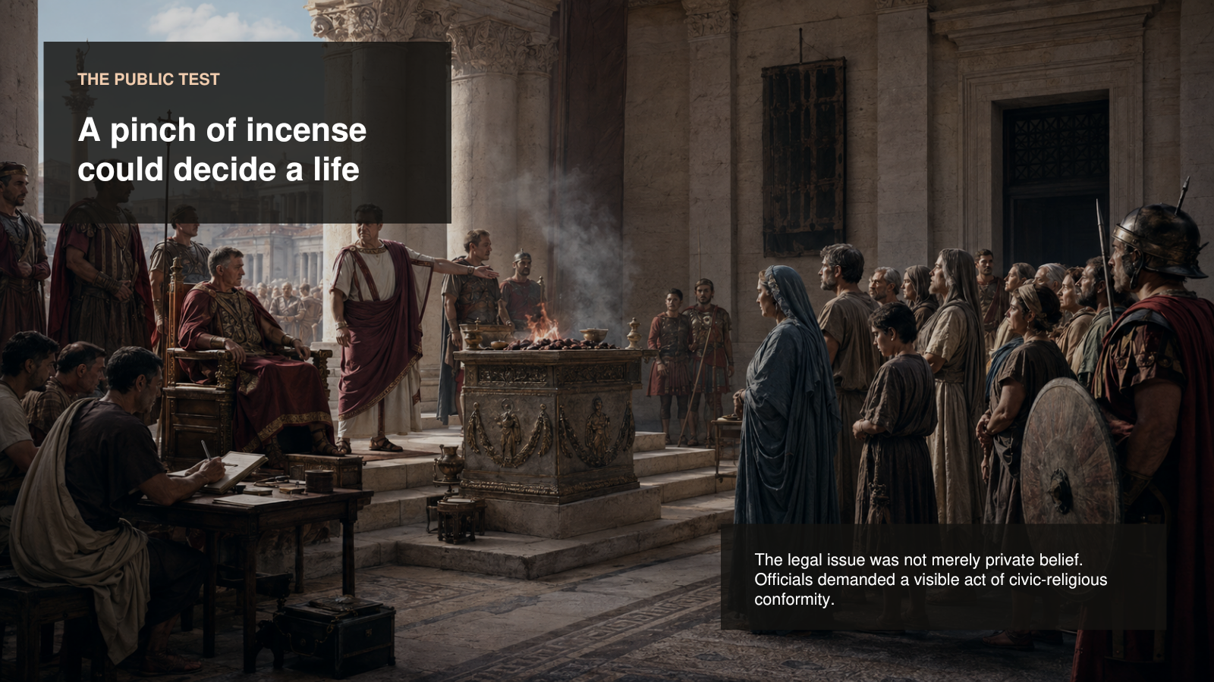
PowerPoint slide 10
CORE CLAIM The tribunal forced Christians to make an embodied, public choice between religious conformity and refusal.

Historical Background
Roman sacrifice could involve incense, wine, an animal offering, or eating sacrificial food. The exact demand varied. The central purpose was visible compliance. Officials sometimes tried repeatedly to persuade Christians because Roman administration generally preferred obedience to creating martyrs. Christian defendants understood the requested act as worship of another god and denial of their allegiance to Christ. The trial therefore concentrated a vast political-religious conflict into one bodily action.

Suggested Presentation Narrative
Direct attention to the altar, official, clerk, soldiers, and assembled families. Explain that the clerk matters: the trial was a legal proceeding, not merely a street confrontation. The family group matters because universal sacrifice could reach men, women, and children. The altar matters because the state demanded an observable act. The visual should help the class feel how something apparently small could carry enormous theological meaning.
Accuracy guardrail. The reconstruction includes a visible cross-like object in the wider architectural scene; do not use it as evidence for a specific documented processional practice at this tribunal.
Transition. The same edict did not create the same danger everywhere. Geography and political authority changed its meaning.

SLIDE 11

One Law Produced Different Regional Realities
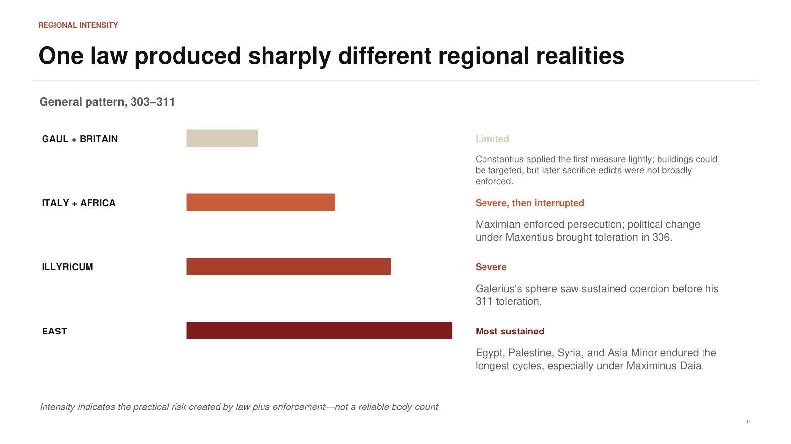
PowerPoint slide 11
CORE CLAIM Persecution was lightest in Constantius’s far West and generally longest and harshest in the eastern provinces.

Historical Background
In Gaul and Britain, Constantius appears to have limited enforcement chiefly to the first edict and the destruction of some buildings. Italy and Africa experienced serious measures under Maximian, but political change under Maxentius brought an earlier relaxation. Galerius’s territories endured sustained pressure. Egypt, Palestine, Syria, and Asia Minor experienced the longest cycles, particularly under Maximinus Daia, who continued or renewed coercion even after Galerius moved toward toleration.

Suggested Presentation Narrative
Explain that the bars measure qualitative intensity, not deaths. Use the slide to ask a hypothetical question: “If you were a Christian in Britain and your cousin lived in Palestine, would the phrase ‘the persecution’ describe the same daily experience?” The answer is no. Both lived under the shadow of imperial policy, but the practical risks differed substantially.
Accuracy guardrail. Do not convert this qualitative graphic into numerical claims. The evidence cannot support precise empire-wide regional casualty comparisons.
Transition. The contrast becomes clearest when the far West is placed directly beside Egypt, Palestine, and Syria.

SLIDE 12

Geography Could Mean Demolition or Death
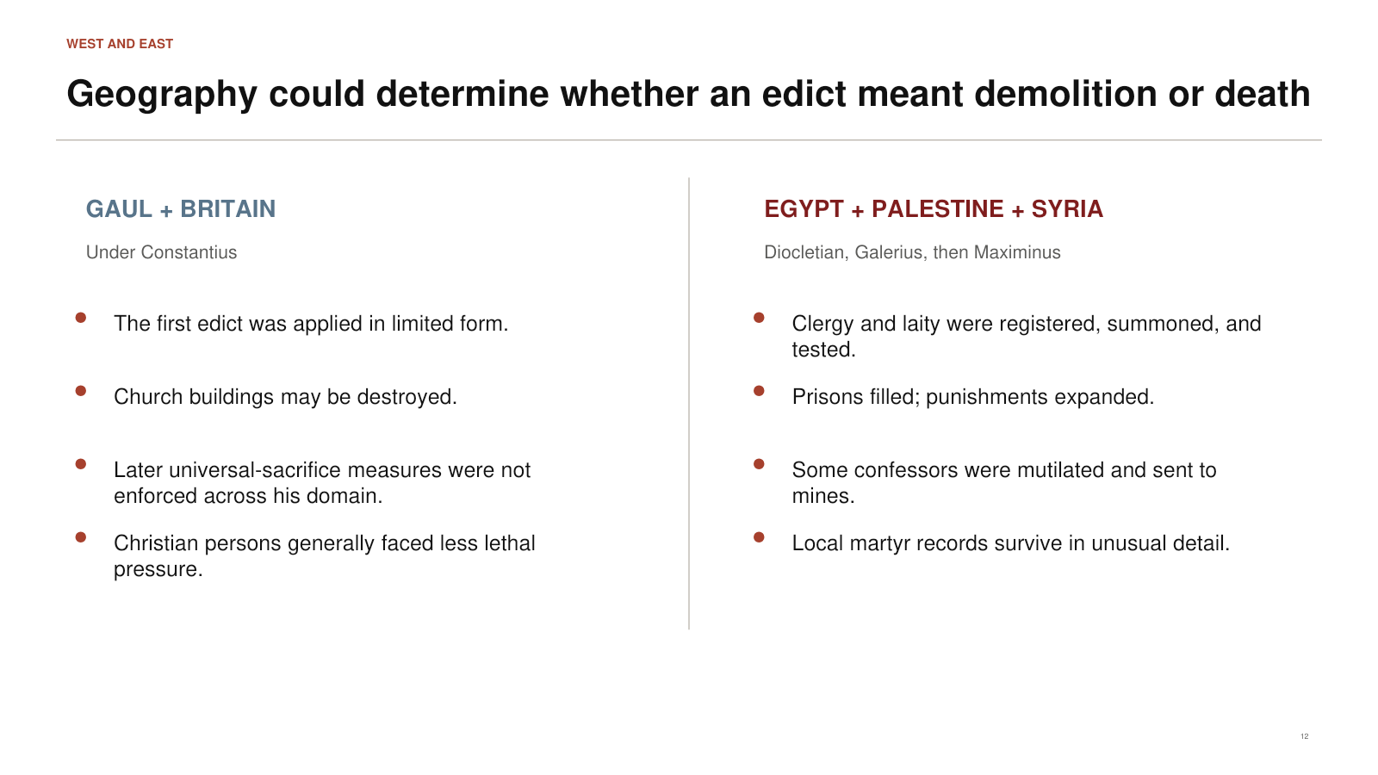
PowerPoint slide 12
CORE CLAIM A Christian’s location could determine whether the main threat was property loss or sustained physical coercion.

Historical Background
Constantius’s government in Gaul and Britain did not pursue the later sacrifice measures with the severity found farther east. Christian buildings could still be attacked, so “mild” must not be confused with full religious liberty. In the East, officials used censuses and civic lists to summon residents, filled prisons with clergy, inflicted disabling punishments, deported confessors, and carried out executions. Eusebius’s Martyrs of Palestine gives unusually detailed local testimony.

Suggested Presentation Narrative
Present the slide as a controlled comparison. On the left, explain limited enforcement: damaged buildings and legal pressure, with fewer lethal consequences. On the right, describe a sustained system that followed Christians through arrest, trial, prison, mutilation, mines, and execution. Then remind the audience that the eastern side is also better documented. More evidence does not automatically equal a proportionately larger population of victims.
Accuracy guardrail. Eusebius was an eyewitness to parts of the eastern persecution, but his account is selective and intentionally commemorative.
Transition. Under pressure, Christians did not survive only through public courtroom confession. Much Christian endurance remained quiet and hidden.

SLIDE 13

The Church Survived in Homes and Hidden Books
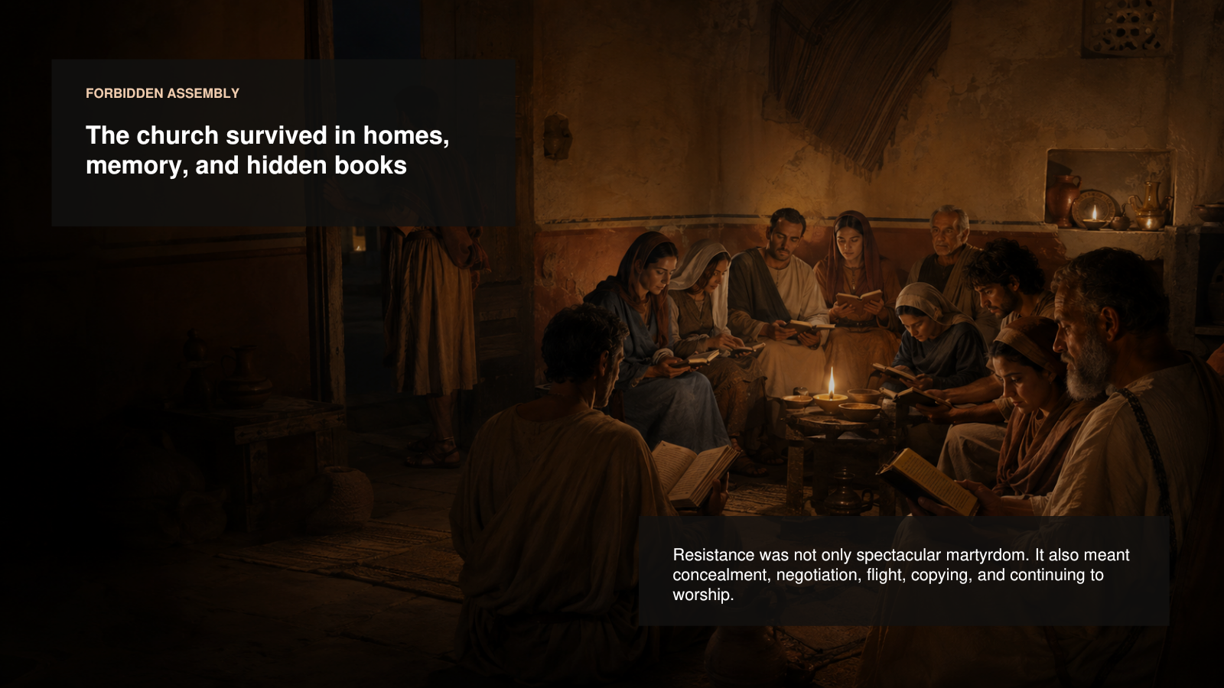
PowerPoint slide 13
CORE CLAIM Christian resistance included ordinary acts of preservation, secrecy, movement, and continued worship.

Historical Background
Martyr narratives naturally remember extraordinary courage, but documentary evidence exposes less dramatic strategies. Congregations could conceal property, move books, negotiate inventories, use personal connections, flee, or meet in private homes. A papyrus from Oxyrhynchus records the confiscation of church property through official channels. Another private letter shows the troubling problem of sacrifice being performed through another person. These documents reveal blurred moral and practical choices.

Suggested Presentation Narrative
Tell the audience that survival is often quieter than martyrdom. The image shows Christians reading codices at night while someone watches the door. It does not portray a specific named gathering. It represents the broader reality that Christian identity continued through worship, teaching, memory, and communal care. Emphasize that the church preserved Scripture not only through heroic refusal to surrender books but also through copying, concealment, and dispersion.
Accuracy guardrail. Do not imply that every congregation went underground or that every private house gathering was illegal in precisely the same way throughout the decade.
Transition. The quieter evidence should stand beside the named individuals and communities remembered for public refusal.

SLIDE 14

Named Cases Reveal a Range of Outcomes
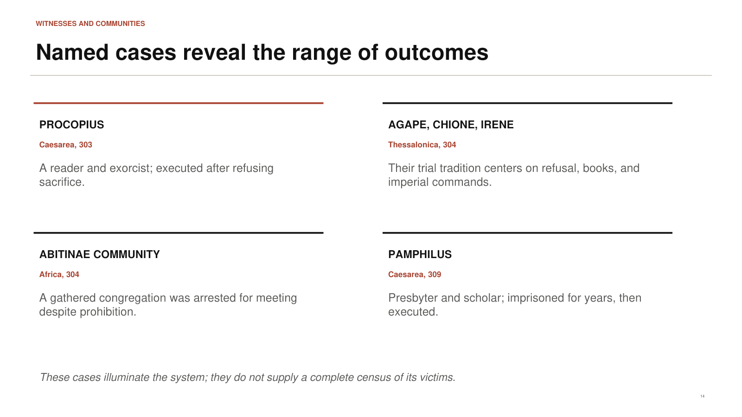
PowerPoint slide 14
CORE CLAIM Representative cases illuminate the persecution without providing a complete census of its victims.

Historical Background
Procopius was a church reader and exorcist executed at Caesarea in 303 after refusing sacrifice. Traditions concerning Agape, Chione, and Irene place three Christian women before authorities at Thessalonica in 304 and connect their prosecution with imperial commands and Christian books. The Abitinae Christians in North Africa were arrested after meeting for worship despite prohibition. Pamphilus of Caesarea, a presbyter and scholar associated with the biblical library there, endured extended imprisonment before execution in 309.

Suggested Presentation Narrative
Do not rush through the names. Use each to show a different dimension: Procopius represents the judicial test; the Thessalonian women connect refusal and books; Abitinae shows that an entire worshiping community could be targeted; Pamphilus shows long imprisonment and the intellectual life of the church. The purpose is not to create a dramatic roll call but to show how the legal system touched readers, women, congregations, clergy, and scholars.
Accuracy guardrail. Martyr acts differ in textual history and historical reliability. Anchor claims in early evidence and avoid embellishing torture details from much later legends.
Transition. Execution was not the only severe punishment. Some confessors were kept alive and sent into a system of forced labor.

SLIDE 15

Exile, Mutilation, and the Mines
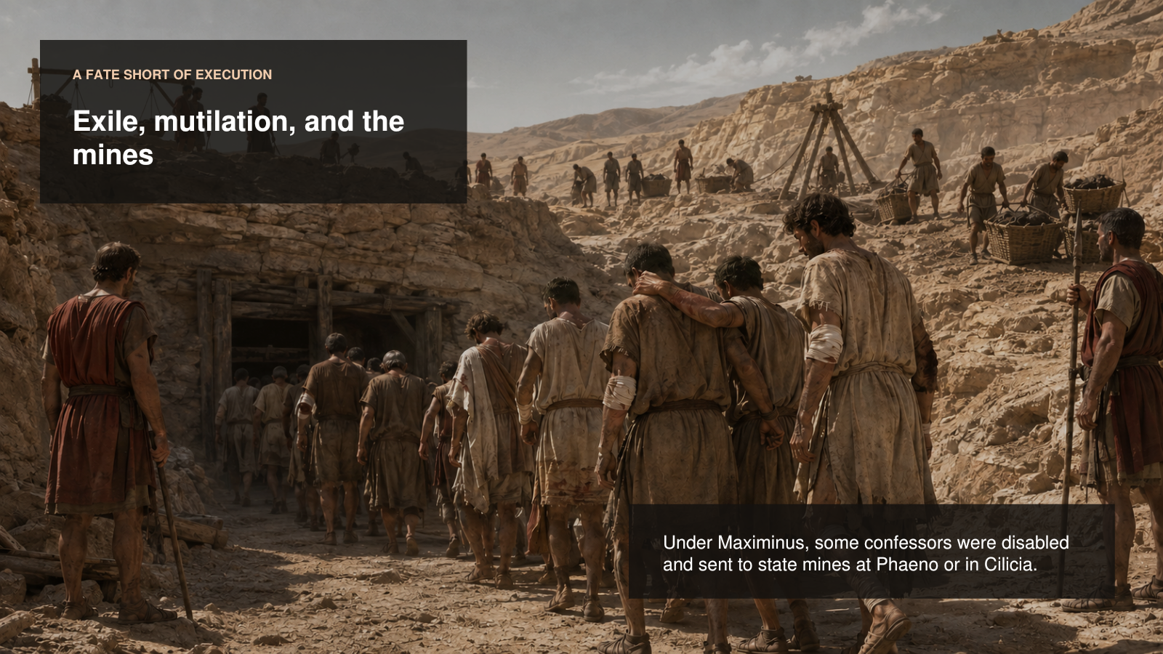
PowerPoint slide 15
CORE CLAIM The state used disability, deportation, and forced labor as alternatives to immediate execution.

Historical Background
Eusebius reports that under Maximinus Daia some Christian confessors had an eye injured or a leg tendon disabled and were then sent to state mines. Phaeno, in the region south of the Dead Sea, was associated with copper mining and harsh labor. Others were sent to Cilicia. This punishment removed Christians from their communities, made them economically useful to the state, and displayed imperial control over their bodies.

Suggested Presentation Narrative
Describe the visual soberly. The prisoners support one another as they approach a mine entrance. The image intentionally avoids graphic injury. Explain that ancient mines were physically destructive environments and that mutilation made the sentence even more severe. A “confessor” in this context is a Christian who publicly confessed the faith and suffered for it but was not necessarily killed.
Accuracy guardrail. Do not call every mine prisoner a martyr in the strict sense. In early Christian usage, a martyr dies for the testimony; a confessor may survive severe suffering.
Transition. Between martyrdom and total surrender lay a broad range of choices that later Christians had to evaluate.

SLIDE 16

Most Choices Lay Between Heroic Extremes
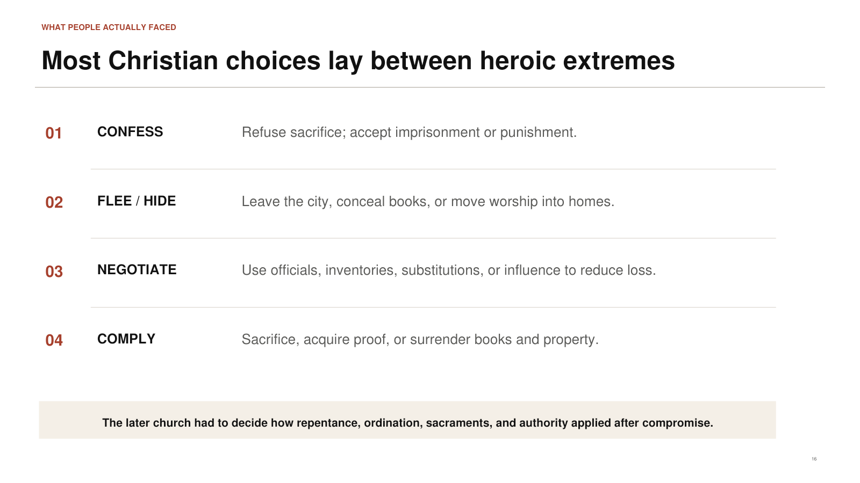
PowerPoint slide 16
CORE CLAIM Christians responded through confession, flight, concealment, negotiation, proxy action, and compliance.

Historical Background
Christian literature often contrasts the faithful martyr with the apostate, but lived experience was more complicated. Some openly refused sacrifice. Some left their cities or hid. Some surrendered ordinary books while concealing Scriptures. Some used intermediaries or influence. Some sacrificed and later sought restoration. Church councils after persecution had to determine appropriate repentance and readmission for different degrees of compromise.

Suggested Presentation Narrative
Use the four categories as teaching aids, not moral boxes. Explain that terror compresses decision-making. A person might protect children, fear torture, misunderstand what was demanded, or later repent deeply. The early church still treated idolatry and betrayal seriously, but it also had to practice pastoral judgment. This slide prepares the audience to understand why post-persecution controversies became so intense.
Accuracy guardrail. Avoid judging every historical person’s motives when the evidence records only an action or accusation.
Transition. The most explosive accusations concerned clergy who allegedly surrendered Scriptures or church property.

SLIDE 17

The Persecution Continued After the Prisons Opened
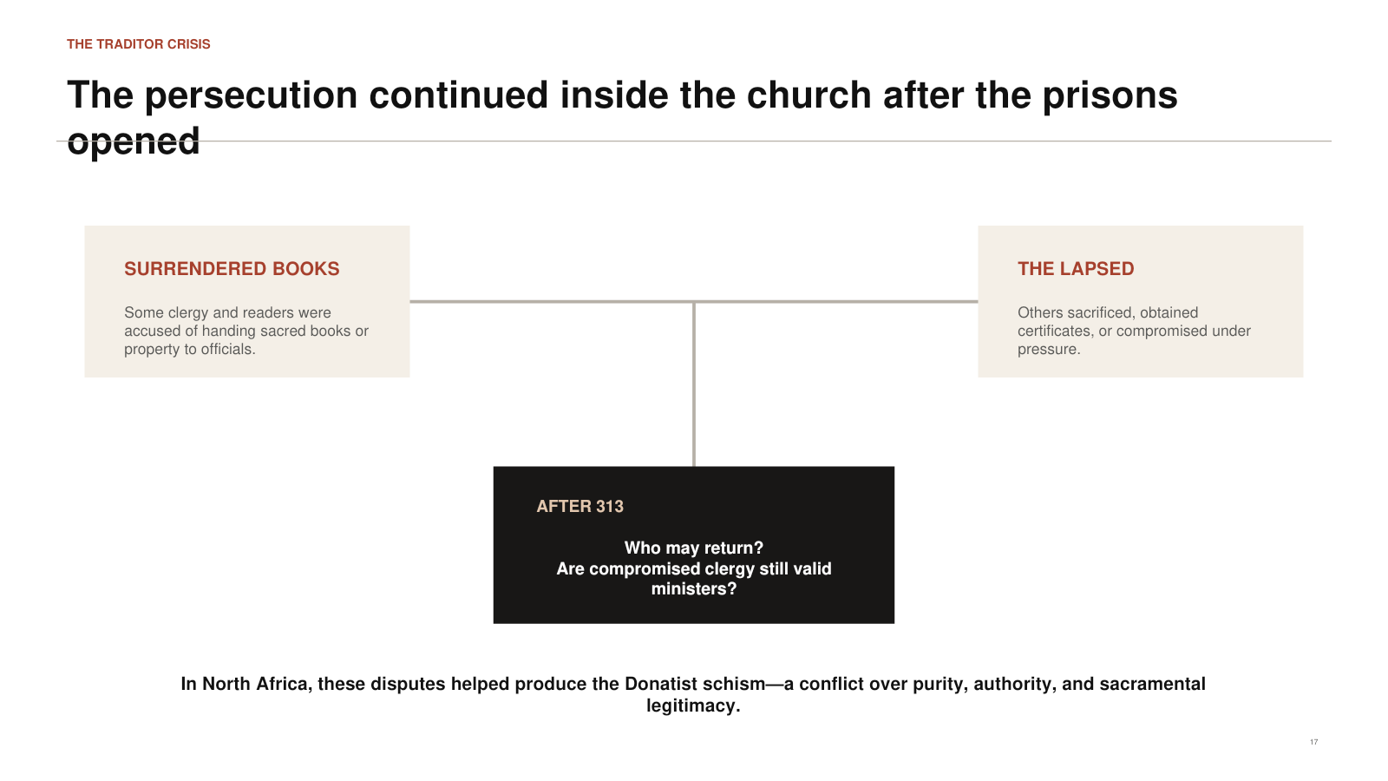
PowerPoint slide 17
CORE CLAIM Disputes over the lapsed and the traditores turned memories of persecution into a crisis of church authority.

Historical Background
The Latin verb tradere means “to hand over.” A traditor was someone accused of handing sacred books or church property to Roman officials. The lapsed were Christians who compromised, especially through sacrifice. After toleration, congregations asked whether the compromised could return, what repentance was required, and whether sacraments performed by an allegedly unfaithful minister remained valid. In North Africa, disputes about contested bishops and the purity of the church contributed to the Donatist schism.

Suggested Presentation Narrative
Draw attention to the two paths converging on the central question. The issue was not merely personal forgiveness. It involved ordination, episcopal succession, sacramental validity, and the identity of the true church. Explain that Donatists emphasized a pure church and rejected the authority of clergy they considered compromised. Their opponents held that the validity of the sacrament ultimately depended on Christ rather than the moral perfection of the minister.
Accuracy guardrail. Do not reduce the Donatist controversy to one simple disagreement or suggest that every accusation of being a traditor was proven.
Transition. These church conflicts unfolded while the imperial government itself was breaking apart after Diocletian’s abdication.

SLIDE 18

Diocletian’s Abdication Did Not End the Persecution
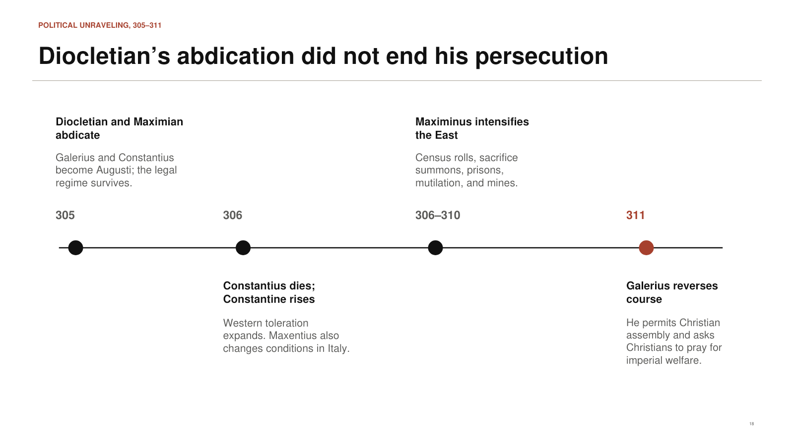
PowerPoint slide 18
CORE CLAIM The policy survived its founder because successor emperors inherited both the laws and competing regional agendas.

Historical Background
Diocletian and Maximian abdicated on 1 May 305. Galerius and Constantius became Augusti, while new Caesars entered the system. Constantius died in 306, and his army acclaimed Constantine. Maxentius seized power in Italy. Maximinus Daia governed parts of the East and intensified coercion. The planned succession system fractured into rival claims and civil wars. Religious policy increasingly followed those rival rulers.

Suggested Presentation Narrative
Move along the timeline and emphasize a crucial point: Diocletian leaving office did not repeal the edicts. In the West, Constantine and Maxentius created more favorable conditions. In the East, Maximinus could increase pressure. This is why the phrase “Diocletianic Persecution” can mislead if it makes the audience think Diocletian personally directed every later arrest through 313.
Accuracy guardrail. Keep the succession explanation simple. The full civil-war chronology is complicated and can distract from the religious-policy point.
Transition. The first major empire-level reversal came not from Constantine, but from the dying Galerius in 311.

SLIDE 19

Galerius Permits Christians to Exist and Assemble
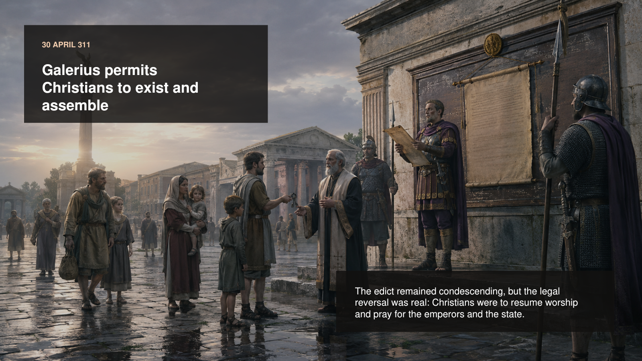
PowerPoint slide 19
CORE CLAIM The 311 toleration ended official persecution in Galerius’s territories and acknowledged that coercion had failed.

Historical Background
On 30 April 311, Galerius issued a toleration preserved in Lactantius and in Greek translation by Eusebius. The document still described Christianity contemptuously, but it allowed Christians to exist again and rebuild their assemblies, provided they did nothing contrary to public order. It also asked Christians to pray for the emperors, the state, and themselves. The request recognized Christian prayer as potentially useful to imperial welfare.

Suggested Presentation Narrative
Present the moment as a real reversal without turning it into a conversion scene. Galerius did not write like a Christian believer celebrating the gospel. He wrote like an emperor ending an unsuccessful policy and seeking stability. Yet the legal change mattered enormously: the state that had tried to eliminate Christian assemblies now permitted them and requested their prayers.
Accuracy guardrail. Do not say that the 311 edict restored all confiscated property. Comprehensive restitution belongs especially to the 313 settlement.
Transition. Even 311 did not end persecution everywhere, because Maximinus controlled important eastern territories.

SLIDE 20

The Persecution Ended in Stages
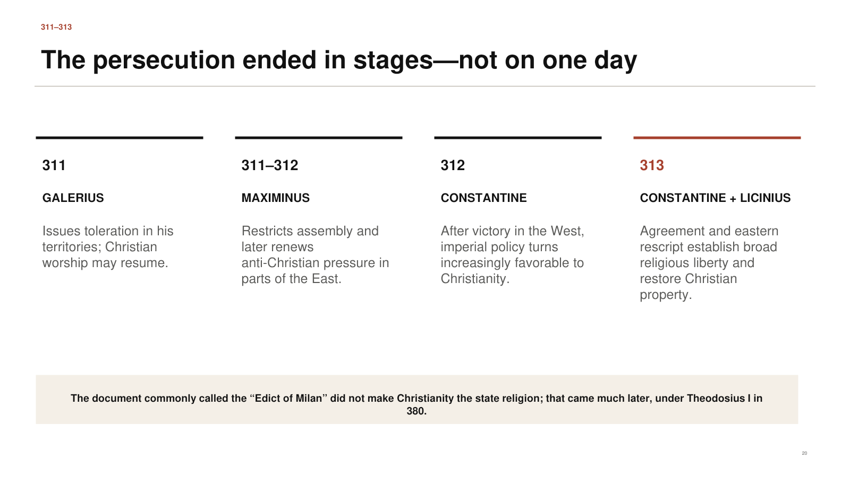
PowerPoint slide 20
CORE CLAIM Galerius’s toleration, Constantine’s rise, Maximinus’s defeat, and the 313 settlement ended the campaign through successive political changes.

Historical Background
Maximinus Daia complied incompletely with Galerius’s toleration and later renewed restrictions and pressure in parts of the East. Constantine’s victory over Maxentius in 312 transformed western imperial politics. In 313 Constantine and Licinius agreed on broad religious liberty. Licinius then defeated Maximinus and published the eastern rescript preserved by Lactantius and Eusebius. This order protected worship and commanded restoration of Christian corporate property.

Suggested Presentation Narrative
Use the four dates as a staircase rather than a single finish line. Galerius stopped official persecution in his sphere. Maximinus complicated that peace. Constantine’s western victory changed the balance of power. The 313 agreement and Licinius’s victory extended a more comprehensive settlement eastward. Explain that historians conventionally call the document the “Edict of Milan,” though what survives is imperial correspondence implementing the agreement.
Accuracy guardrail. Do not say that the Edict of Milan made Christianity the official state religion. Nicene Christianity received official imperial establishment under Theodosius I in 380.
Transition. The legal settlement restored far more than permission to survive, but it could not erase the damage already done.

SLIDE 21

313 Restored Legal Space but Not the Decade
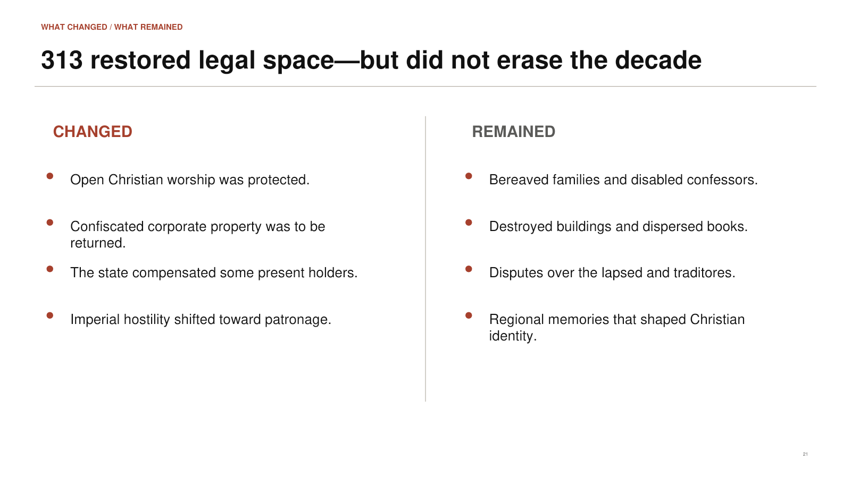
PowerPoint slide 21
CORE CLAIM The 313 settlement protected worship and restored property, while trauma and internal conflict remained.

Historical Background
The surviving rescript ordered Christian meeting places and other corporate property to be returned without payment by the churches. Present holders could seek compensation from the imperial treasury. This was not merely private toleration. It recognized Christian communities as bodies capable of possessing property and gathering openly. Constantine’s later patronage moved beyond neutrality by favoring church construction, clergy, and Christian institutions.

Suggested Presentation Narrative
Contrast the two columns. What changed? Worship could be public, property could be restored, and imperial hostility gave way to legal protection and eventually patronage. What remained? Families had lost loved ones; confessors carried disabilities; congregations had lost books and buildings; accusations of compromise divided churches. Political peace does not instantly create ecclesial or emotional peace.
Accuracy guardrail. Distinguish the 313 settlement itself from all later Constantinian policies. The wider “Constantinian shift” unfolded over time.
Transition. The entire story can now be summarized with four words: systematic, unequal, costly, and unsuccessful.

SLIDE 22

The Campaign Was Systematic, Unequal, Costly, and Unsuccessful
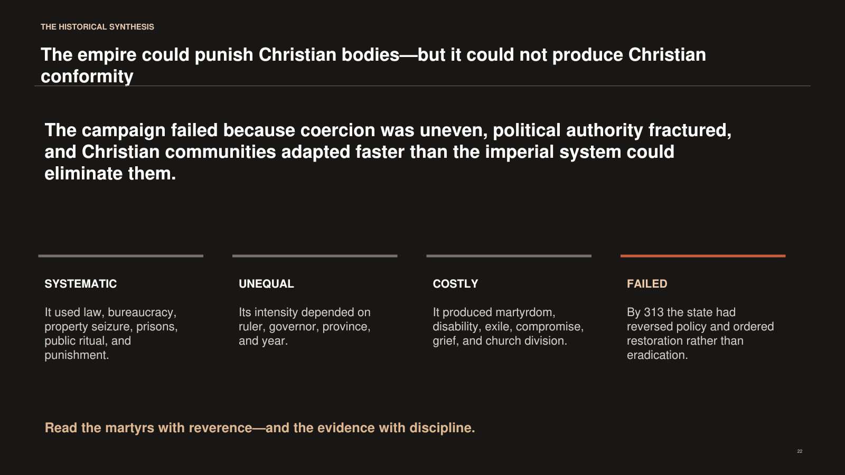
PowerPoint slide 22
CORE CLAIM Roman power inflicted devastating harm but failed to force durable Christian conformity or eliminate the church.

Historical Background
The campaign was systematic because it used legislation, property law, officials, courts, prisons, public sacrifice, exile, mines, and execution. It was unequal because enforcement changed by region and ruler. It was costly because it produced death, disability, displacement, compromise, and division. It was unsuccessful because the state reversed its policy and restored the communities it had tried to dismantle.

Suggested Presentation Narrative
Return to the opening image. The empire could demolish a building and burn physical books, but Christian communities preserved worship, teaching, memory, and identity. Do not make the conclusion triumphalistic in a shallow way. The persecution failed politically, but real people suffered and some churches fractured. Close the original 22-slide sequence with the sentence printed at the bottom: “Read the martyrs with reverence—and the evidence with discipline.”
Accuracy guardrail. Avoid implying that persecution automatically strengthened every congregation or that suffering was evenly distributed.
Transition. The final map section now places this entire narrative onto the geography of the Roman Empire.

SLIDE 23

The Attacks Followed the Empire’s Political Geography
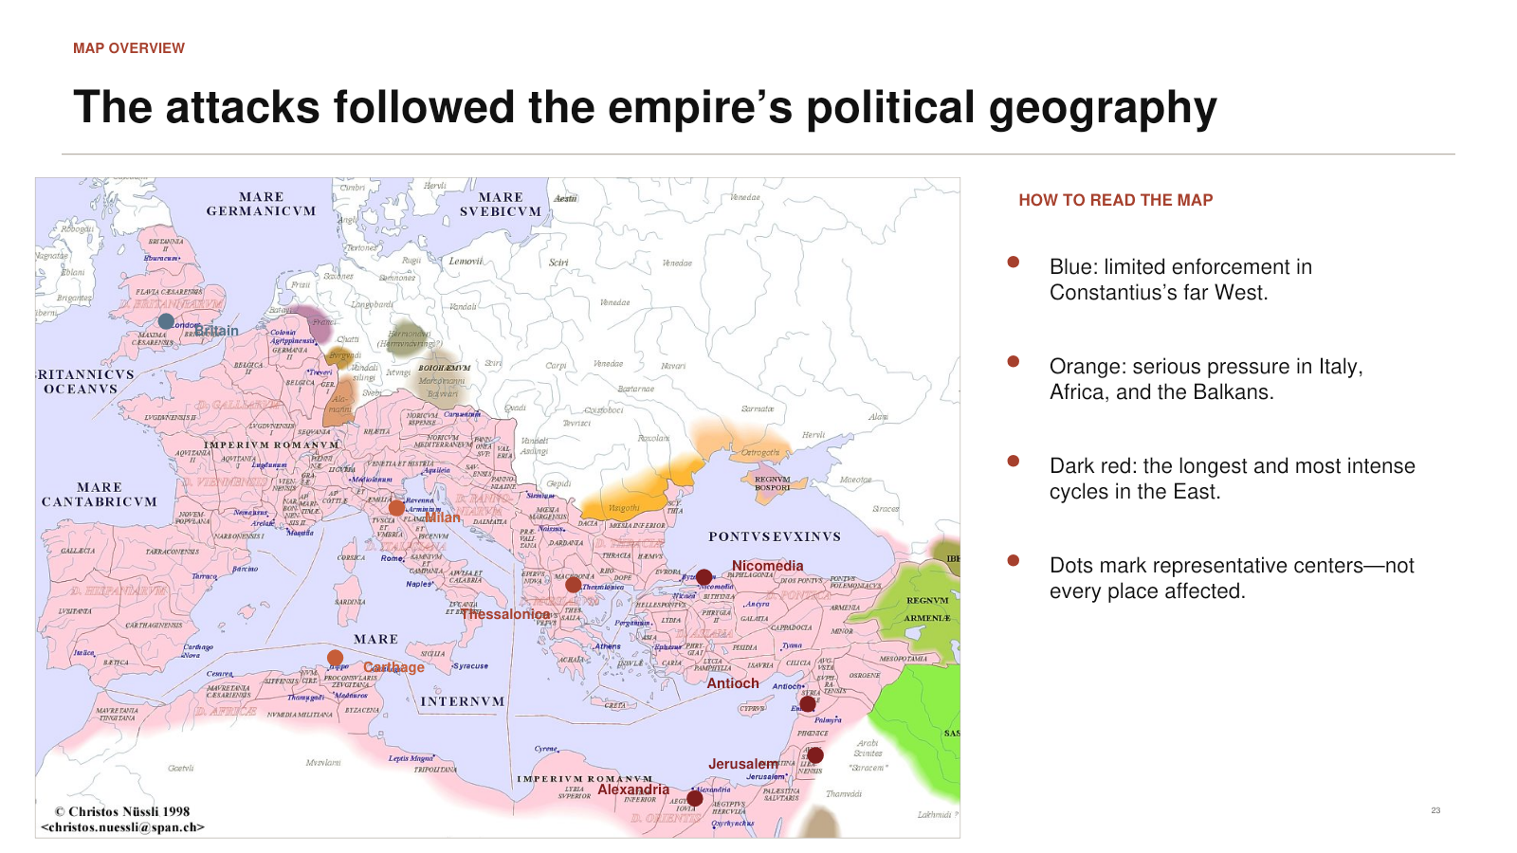
PowerPoint slide 23
CORE CLAIM Representative centers form a west-to-east gradient that corresponds broadly to different imperial administrations.

Historical Background
The map marks Britain, Milan, Carthage, Thessalonica, Nicomedia, Antioch, Jerusalem, and Alexandria as representative centers or regions. They should not be interpreted as the only locations affected. The legal campaign extended across the empire, but the marked points help connect narrative evidence with geography. The far West shows limited enforcement under Constantius. Italy and Africa experienced serious pressure. The Balkans and East became the principal corridor of sustained coercion.

Suggested Presentation Narrative
Orient the audience first: Britain is at the upper left; North Africa lies below Italy; Nicomedia sits near the Bosporus; Antioch, Palestine, and Egypt occupy the eastern Mediterranean. Then explain the colors. Blue indicates the comparatively restrained West, orange represents serious pressure in Italy, Africa, and the Balkans, and dark red represents the longest eastern cycles. State clearly that intensity is qualitative.
Accuracy guardrail. The map is a modern historical map of the empire around 300, not an ancient Roman map and not a statistical heat map.
Transition. Begin the regional tour in the West, where two very different patterns existed side by side.

SLIDE 24

Western Enforcement Ranged from Restraint to Severity
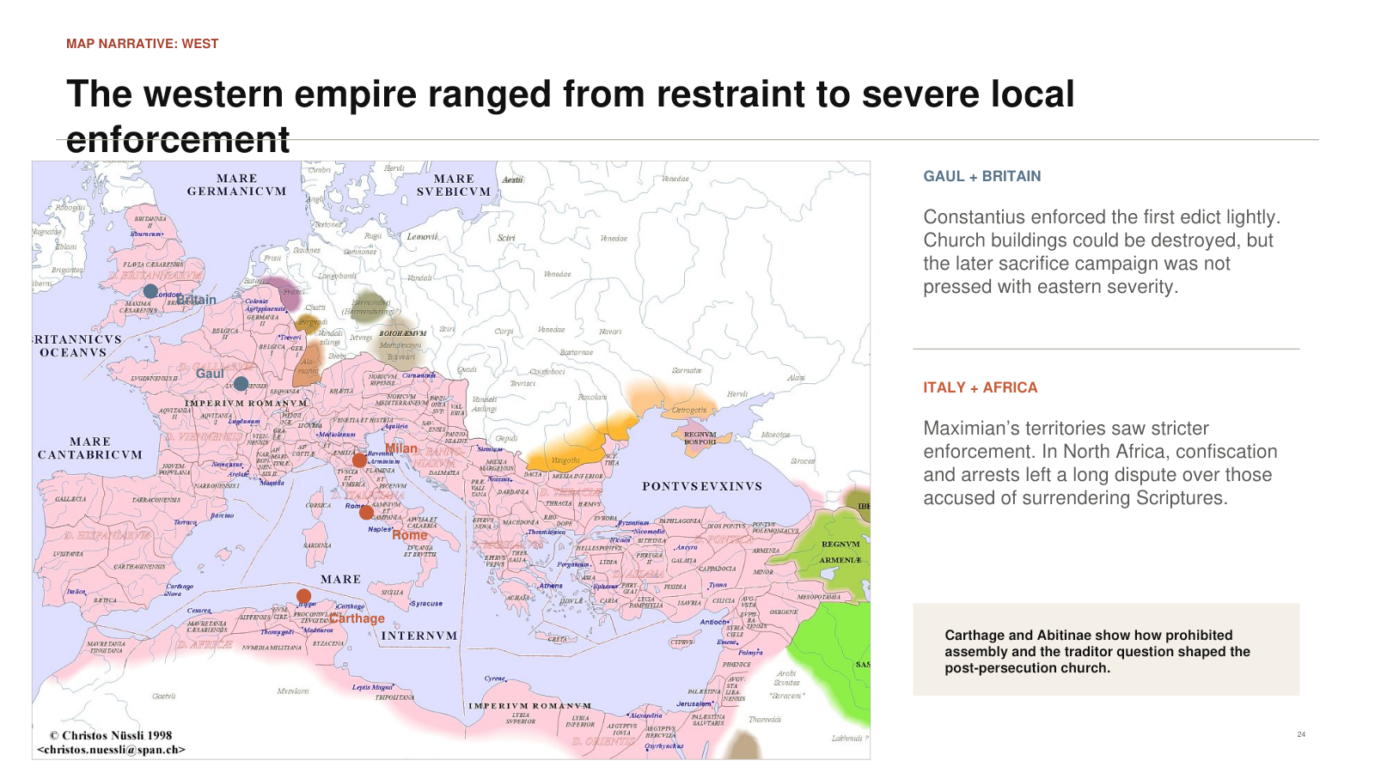
PowerPoint slide 24
CORE CLAIM Constantius’s Gaul and Britain were comparatively restrained, while Maximian’s Italy and Africa experienced substantial enforcement.

Historical Background
In the far West, Constantius appears to have complied with the first edict mainly by destroying some church buildings while avoiding the later and more lethal measures. Italy and North Africa stood under a different ruler and experienced stronger enforcement. North African evidence records confiscation, arrest for prohibited assembly, and later controversies over surrendered Scriptures. Political change under Maxentius in 306 brought toleration earlier than in much of the East.

Suggested Presentation Narrative
Point first to Britain and Gaul. Say that Christians there were not living under modern freedom, but the state did not pursue the full eastern sequence. Then move to Milan, Rome, and Carthage. Explain that crossing an administrative boundary could change the practical danger. Use Carthage to connect geography with the later Donatist controversy: the memory of who stood firm and who handed over books became a long-term question of legitimacy.
Accuracy guardrail. Do not say there were no western martyrs or no suffering. The claim is comparative restraint, not complete immunity.
Transition. Moving eastward brings us toward the imperial court, the Balkans, and the administrative routes through which the edicts spread.

SLIDE 25

Imperial Policy Moved East Through Provincial Networks
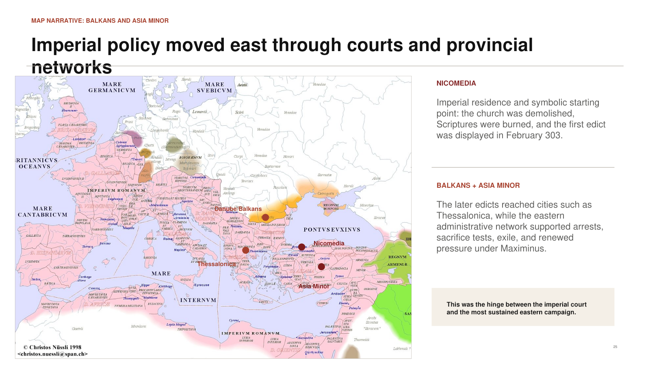
PowerPoint slide 25
CORE CLAIM Nicomedia, the Balkans, and Asia Minor linked imperial decision-making to sustained provincial enforcement.

Historical Background
Nicomedia was Diocletian’s eastern residence and the symbolic opening site of the persecution. The Balkans lay within the political and military world associated with Galerius. Thessalonica provides evidence for application of the sacrifice measures. Asia Minor contained major cities, roads, provincial governments, and Christian communities that could be reached through the imperial administrative network. After 305, Maximinus Daia became a major driver of eastern coercion.

Suggested Presentation Narrative
Use the map to show movement rather than isolated dots. Begin at Nicomedia, where the first church was demolished. Move westward into the Balkans and southward through Asia Minor. Explain that Roman roads, provincial capitals, and official correspondence allowed policy to travel. The same infrastructure that held the empire together could organize a religious campaign across enormous distances.
Accuracy guardrail. Do not imply that persecution spread as one marching army from Nicomedia. Edicts moved through administrative channels and were implemented locally.
Transition. The richest surviving local evidence comes still farther southeast—from Palestine, Syria, and Egypt.

SLIDE 26

Palestine and Egypt Preserve the Clearest Eastern Record
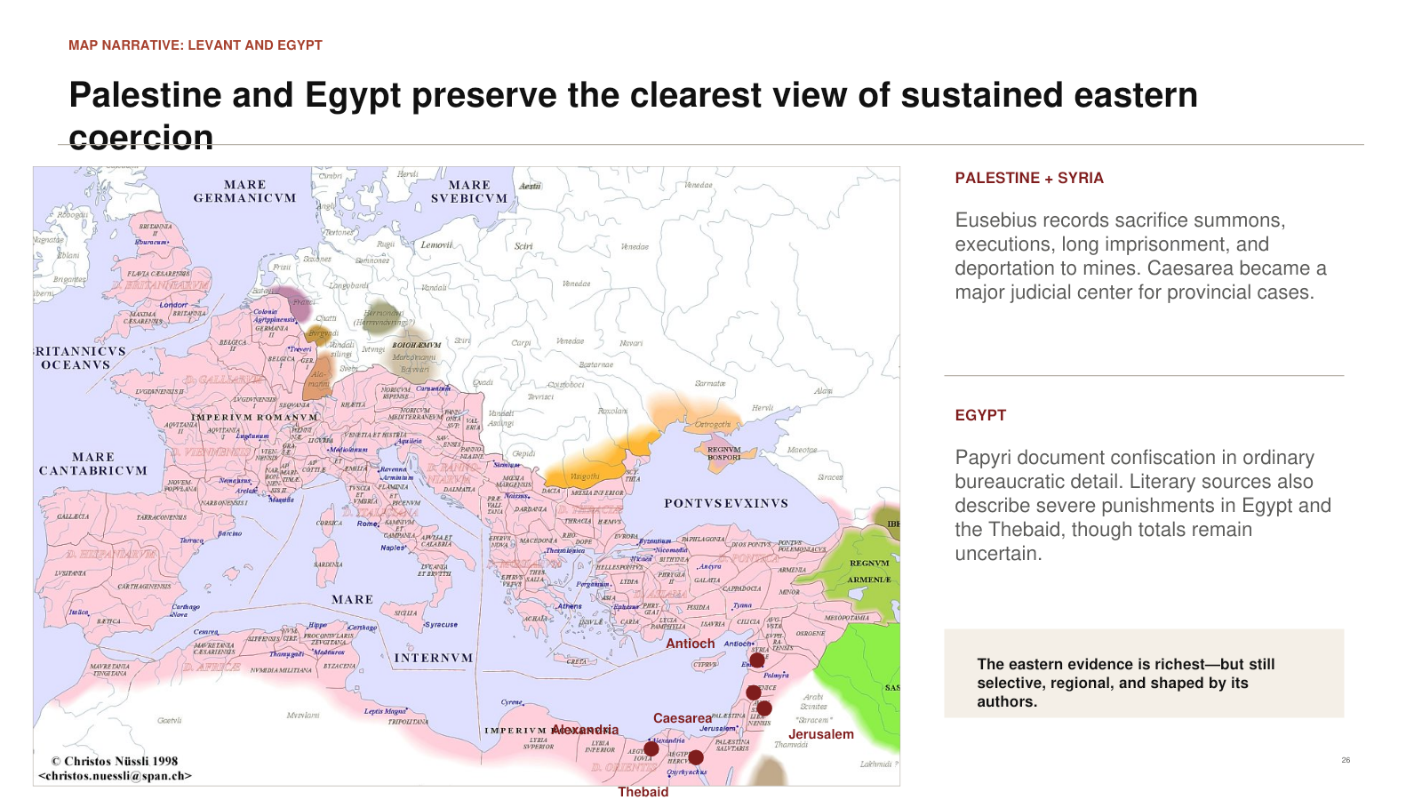
PowerPoint slide 26
CORE CLAIM Eastern literary and documentary evidence allows the most detailed reconstruction, while remaining selective and incomplete.

Historical Background
Eusebius lived through the persecution in Caesarea and traveled in the region. His Martyrs of Palestine records trials, imprisonment, punishments, and executions connected with governors such as Urbanus and Firmilianus. Antioch was an important imperial and provincial center. Caesarea functioned as the capital of Roman Palestine, so cases requiring a governor’s judgment could be brought there. Egyptian papyri independently reveal confiscation and private attempts to navigate sacrifice demands.

Suggested Presentation Narrative
Point to Antioch, Caesarea, Jerusalem, Alexandria, and the Thebaid. Explain that this region does not matter only because persecution was severe; it also matters because evidence survived. Eusebius gives an explicitly Christian commemorative narrative. Papyri give us routine legal and private documents. When these different types of evidence converge, confidence increases. When only one rhetorical source makes an extraordinary claim, caution should increase.
Accuracy guardrail. Do not turn phrases such as “innumerable martyrs” into precise totals. Ancient authors often used such language rhetorically to communicate scale.
Transition. End by returning to the map as a picture of one empire, many administrations, and many Christian experiences.

Questions You Should Be Ready to Answer

Was Diocletian personally responsible for everything through 313?
No. He initiated the campaign as senior emperor, but other tetrarchs and successors shaped enforcement after his 305 abdication.

How many Christians were killed?
No defensible exact empire-wide number survives. Ancient literary language is often rhetorical, and documentation is regionally uneven.

Why not sacrifice outwardly and remain Christian inwardly?
Christians understood sacrifice as worship and covenantal allegiance, not merely a harmless civic gesture.

Did Constantine end the persecution alone?
No. Galerius issued toleration in 311; Constantine transformed the West; Licinius defeated Maximinus and implemented the 313 eastern settlement.

Did the Edict of Milan make Christianity the official religion?
No. It granted broad liberty and property restitution. Official establishment of Nicene Christianity came under Theodosius I in 380.

Did persecution unite all Christians?
It created solidarity and revered martyrs, but it also created disputes over compromise, repentance, clergy, sacraments, and church purity.

Primary Sources and Further Study
Eusebius of Caesarea, Ecclesiastical History, Books 8–10. The central Christian narrative for the persecution, regional experience, imperial reversals, and restoration.
Eusebius of Caesarea, Martyrs of Palestine. The fullest surviving local account of trials and punishments in Palestine.
Lactantius, On the Deaths of the Persecutors, especially chapters 10–15, 34, and 48. A near-contemporary account with valuable court detail and an openly theological, anti-persecutor interpretation.
Annemarie Luijendijk, “Papyri from the Great Persecution: Roman and Christian Perspectives,” Journal of Early Christian Studies 16.3 (2008): 341–369. Documentary evidence for confiscation, bureaucracy, negotiation, and ordinary Christian responses.
The Cambridge History of Christianity, “Constantine and the Peace of the Church.” A modern scholarly overview of the transition from persecution to toleration and imperial patronage.
Christos Nüssli, map of the Roman Empire around AD 300. The geographical base map used in Slides 23–26.

Online Texts Used in the Presentation
- https://sourcebooks.web.fordham.edu/source/persec1.asp
- https://sourcebooks.web.fordham.edu/source/edict-milan.asp
- https://www.ccel.org/ccel/pearse/morefathers/files/eusebius_martyrs.htm
- https://religion.princeton.edu/document/2621
- https://www.fourthcentury.com/diolectian-persecution-chart/
- https://roman-emperors.sites.luc.edu/big300.htm
- https://www.cambridge.org/core/books/abs/cambridge-history-of-christianity/constantine-and-the-peace-of-the-church/1D6492CD5ECB96174AAE1221F48DC56F

